|  |  |
| --- | --- |
| **Student Name and ID Number** | Mithra Ramprabu |
| **Qualification** | Pearson BTEC Higher National Diploma in Computing |
| **Academic Year** | 2023-2024 |
| **Unit Number and Name** | Unit 13: Website Design & Development |
| **Unit Lecturer** | Ms. Lavanya Sreenivas |
| **Assignment Title** | Website Design and Development |
| **Type of Assignment** | Business Report |
| **Issue Date** | 01/04/2024 |
| **Summative Submission Date** | 30/04/2024 |

Table of Contents

1. Explain server technologies and management services associated with hosting and managing websites. 4

1.1.1 What is DNS? 4

1.1.2. How are Domain Names organized? 4

1.1.3 How are Domain Names managed? 7

1.2.1 What are Communication Protocols? 9

1.2.2. What are Server Technologies? 11

1.2.3. Web Server Software 12

1.2.4. Operating Systems 13

1.3. Analyse the impact of common web development technologies and frameworks with regard to website design, functionality and management. 14

1.3.1. Website Design 15

1.3.2. Website Functionality 15

1.3.3. Website Management 16

1.4.1. What is Search engine optimization (SEO)? 17

1.5.1. What is the Front-End? 22

1.5.2. What is the Application Layer? 23

1.5.3. What is the Presentation Layer? 23

1.5.4. Web-based Technologies 23

1.5.5. Management Services 24

1.5.6. Tools and Software 24

1.5.7. Building a Website 25

2. Categorise website technologies, used to  develop websites. 25

2.1.1. About Frontend 25

2.1.2. Frontend Development: 25

2.1.3. Frontend Development Languages 26

2.1.4. What is Backend? 26

2.1.5. Backend Development 26

2.1.6. Backend Development Languages 26

2.1.7. Relationship between Frontend and Backend 27

2.1.8. Difference between Frontend and Backend 27

2.1.9. What is the presentation layer? 27

2.1.10. What is application layer? 29

2.2.1. What is a Website Template? 30

2.2.2. What is a Custom-Built Website? 30

2.2.3. Why use Custom-Built Websites? 30

2.2.4. Performance of websites 31

2.2.5. Functionality 31

2.2.6. User Experience (UX) 32

2.2.7. User Interface (UI) 32

2.3.1. Analyse website technologies, tools and techniques with good design principles to create a multipage website 33

2.3.2. Tools and Techniques to design and develop a custom-built website 33

3.3.3. FrontEnd Frameworks and Libraries 33

2.3.4. BackEnd Frameworks and Languages 35

2.3.5. Databases 36

3. Utilise website technologies, tools, and techniques with good design principles to create a multipage website 38

3.1. SET OF CLIENT AND USER REQUIREMENTS 39

Client Requirements 39

User Requirements 41

3.2. WIREFRAME / DESIGN DOCUMENT FOR WEBSITE 42

3.2.1. What is a Wire Frame? 42

3.3. A branded, multipage website supported with realistic content. 46

3.4. Justification of the multipage website implementation decisions against the design document. 52

3.5. Evaluation of the design and development process of the multipage website against the design document including any technical challenges faced. 53

4. Creation of a suitable test plan, identifying key performance areas to review the functionality and performance of the multipage website developed. 54

4.1.1. Test Plan for We Do Conferences! Multipage Website 54

4.1.1. Analysis of the Quality Assurance (QA) process 56

4.1.2. QA Testing Process 57

4.2.1. Test Plan Results Evaluation 58

4.2.2. Overall Success and Recommendations 59

Figure 1: Wireframe design for the Main page of the website regarding the Black Hole Exploration Conference 42

Figure 2:Wireframe depicting the webpage concerning the 4-day long schedule of the Black Hole Exploration conference 42

Figure 3: Webpage Wireframe regarding bios of speakers present in the Black Hole Space Exploration Conference 43

Figure 4: Ticket pricing and membership options available to interested persons concerning the Black Hole Space Exploration Conference 44

Figure 5: Registration for entry and membership to the Black Hole Space Exploration Conference for interested members and attendees 44

Figure 6:The figure-head page of the Black Hole Space Exploration Conference website. The main page introduces the conference and all related aspects. 45

Figure 7: The above webpage showcases the daily and hourly schedule of the conference. 46

Figure 8: Speaker bios are presented, alongside images to elaborate on esteemed guests of the conference 46

Figure 9: Webpage elucidates the membership options and entry pricing. 47

Figure 10: The registering page for interested attendees. 48

Figure 11: Companies present at conference. 49

Figure 12: Company bios 49

Figure 13: Submission page. 49

Figure 14: Submission page. 50

Figure 15: Q&A 50

Figure 16: Registration records 50

# **WEBSITE DESIGN AND DEVELOPMENT**

## **1. Explain server technologies and management services associated with hosting and managing websites.**

### 1.1.1 What is DNS?

The Domain Name System (DNS) is the phonebook of the Internet. Humans access facts online through domains, like nytimes.com or espn.com. Web browsers interact through Internet Protocol (IP) addresses. The TCP/IP protocol suite uses the DNS protocol. It converts URLs into IP addresses that computers use to identify one another on a network. You can connect to a DNS, which maintains a sizable database of domain names and converts them to IP addresses, without needing everyone's IP address. As a result, when you enter a website address, such as www.google.com, the internet service provider will request the DNS linked with the domain name and then translate it into an IP address that a computer understands and will directly connect to the correct website.

DNS serves for:

•Matching hostnames to IP addresses

•Pointing services

•Directing messages to mail services

•Authentication and validation of emails and different services

•Creating VPN

•Creating a content delivery network

•Load balancing

•Increase your uptime

Each device connected to the Internet has a unique IP code which different machines use to find the device. DNS servers eliminate the need for human beings to memorize IP addresses like 192.168.1.1 (in IPv4), or more complicated, modern alphanumeric IP addresses including 2400:cb00:2048:1::c629:d7a2 (in IPv6).

### 1.1.2. How are Domain Names organized?

URLs: The address of a website that is entered into a browser's address bar is known as a URL.

A URL is one-of-a-kind and cannot be shared between websites, just like a fingerprint is one-of-a-kind for each person. No two fingerprints are identical. A URL is organized by the structure of its various parts. This example, *https://moodle.nptcgroup.ac.uk*, demonstrates the various parts of a URL and how they are organized. The protocol you use to send data between your browser and the website you want to connect to is HTTPS. The name of the web server from which it can be accessed is "Moodle," which serves as the host. The fact that the second-level domain .ac is used by UK universities and colleges indicates that it is an academic domain. Then there is the top-level domain like Generic Top-Level Domains (gTLD). This is the highest level of domain and its top-level domain. The suffix at the end of the URL typically refers to a business (.com), a nation (.fr), or a government (.gov).

Domain names are prepared hierarchically from right to left. For instance, inside the domain name "www.Example.Com":

TLD (Top Level Domain) nameserver: The part of a domain name that comes after the dot is what the TLD nameserver is referring to. There are two types of TLDs: country TLDs and industries TLDs. Take, for instance for government websites and.FR for France. In the root zone of the internet's DNS, the TLD is the highest level of domain names. It is the very last part of the domain name 1 for the other lower-level domains. The Internet Assigned Numbers Authority (IANA), which is a division of ICANN, is in charge of managing the TLD nameservers. Here, ‘.com’ is the TLD.

SLD (Second Level Domain) nameserver: “Example” is an SLD. This is the main name of the website or organization and can be customized if it's available and follows the policies of the selected TLD. www is a subdomain. Subdomains can be created to organize content within a domain, which includes "blog.example.com" for a blog hosted on example.com.

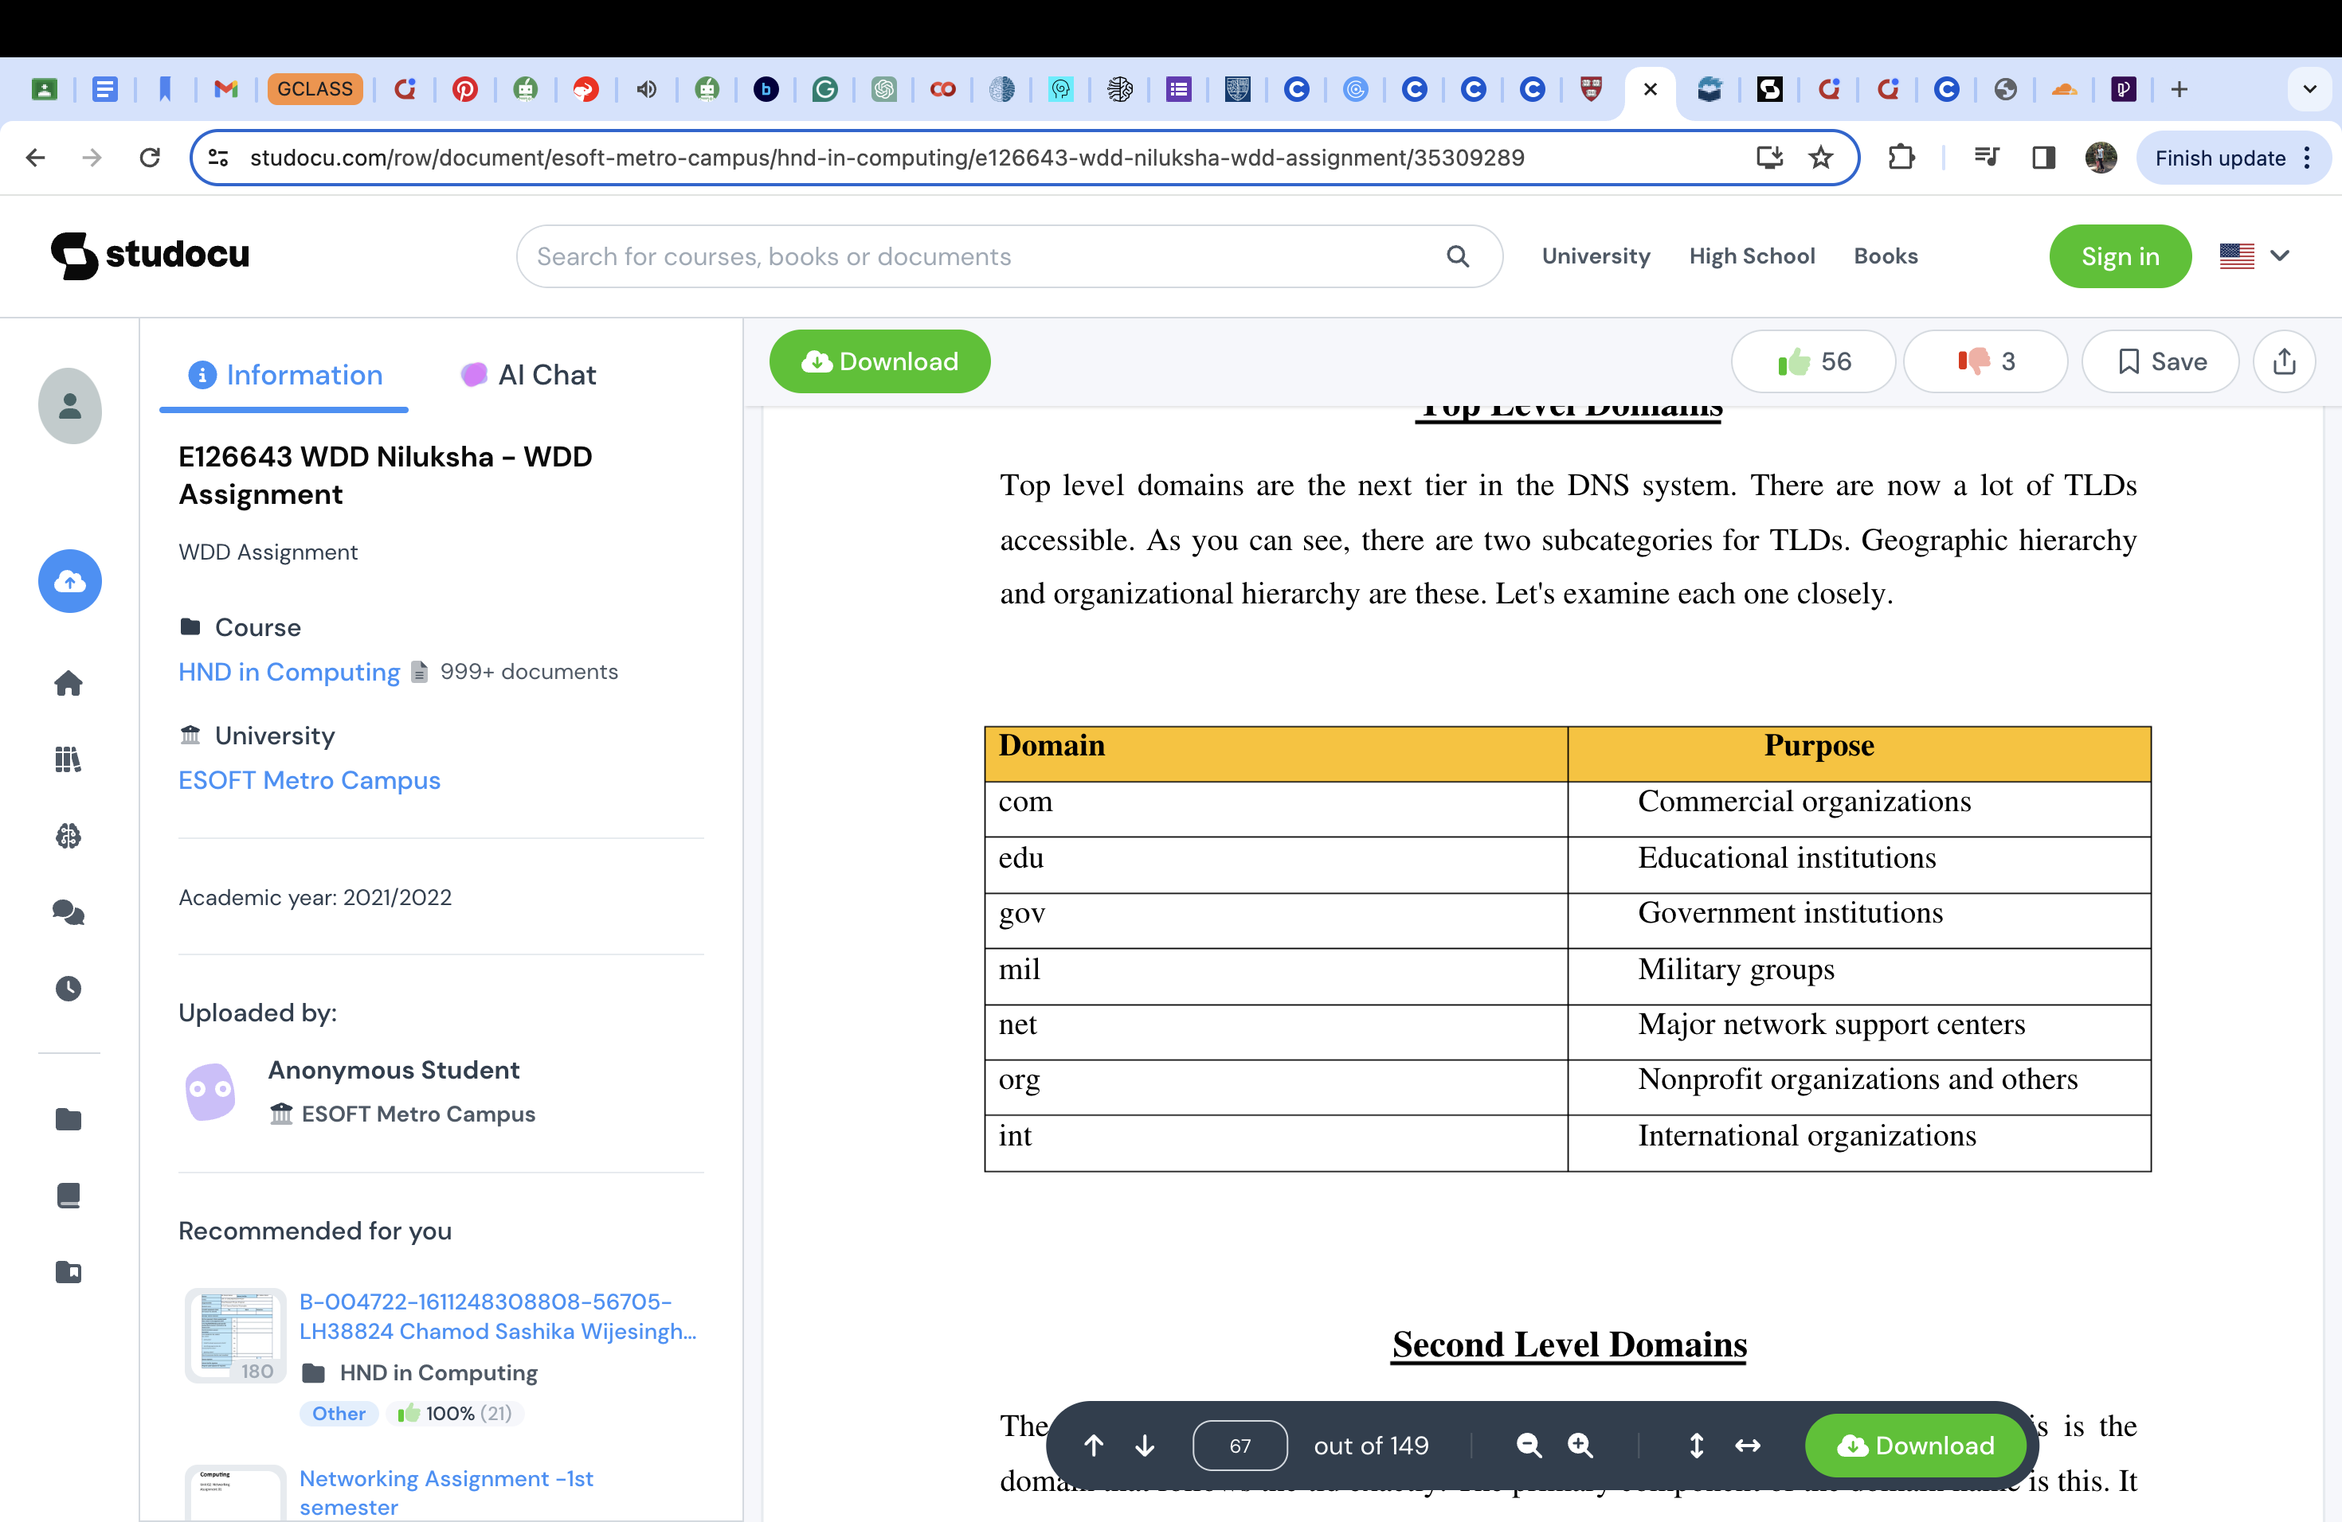

**DNS Servers**:

DNS servers are distributed globally and keep mappings among domain names and IP addresses.

There are unique sorts of DNS servers:

DNS Resolution:

When you input a domain name like "www.example.Com" into your browser or try to access a resource on the internet, your device first examines its local DNS cache to see if the IP address is already saved. If not, it sends a DNS query to a DNS resolver to discover the corresponding IP address.

DNS Iterative server: The iterative DNS query will ask a DNS server for information about a website. The user will enter the website they are trying to find, and the resolver will either provide an answer from its cached memory or ask another DNS server if they have the answer by returning the address of that DNS server. If it is unable to provide a definitive answer, it will ask the next DNS server. The query will begin at the root server and descend the levels in accordance with its received referrals.

DNS Resolver:

Typically supplied using your net carrier company (ISP) or set up manually, the DNS resolver is chargeable for finding the IP address linked to the asked domain name. It does this by sending queries to distinct DNS servers gradually until it locates the authoritative name server for the domain. Once a DNS query has been sent from the client, a recursive resolver will either bring back cached data if it is found in the cache or it will send a request to a root nameserver, then another request to a TLD (Top Level Domain) nameserver, and finally a final request to an authoritative nameserver. A resolver is the first stop in a DNS query. It serves as the middle link between the client and a DNS name server. The recursive resolver will attempt to obtain the requested website's IP address and return it if it does not already have the website in its cache. After that, it will keep this IP address in its memory for some time. The owner of the domain decides how long the website stays in the cache's memory by using a setting called time to live2, which specifies how long it stays there.

Root Name Servers: These serve as the starting point in the DNS lookup method. They offer information about the authoritative name servers for every top-level domain.

Top Level Domain (TLD) Name Servers: These deal with domain names within their specific TLDs (e.g., Com, Org, Internet) and direct the resolver to the best authoritative name server.

Authoritative Name Servers: These servers keep the actual DNS information (e.g., A records, CNAME records) for precise domains. They are the final destination in the DNS lookup and provide the asked IP code. A server that plays a significant role in translating a domain name into an IP address for a computer is the root name server for the DNS records. They respond to requests made in the root zone of the DNS. The records that are cached in the root zone allow the servers to respond to queries. They are also able to divert any other requests that are made to the TLD server.

Authoritative Name Servers: An initial DNS query is answered by an authoritative nameserver. Website responses from the cached memory are not provided. The IP mapping of the website or other server that was searched for is provided by the authoritative nameserver in response to the recursive DNS nameservers. The records for domain names are stored on the authoritative name server. These records can be A, CNAME, MX, NS, SOA, or TXT. For instance, if a DNS server in a network has a record for a website like www.example.co.np, it must be the authoritative server for the example.co.np domain.

DNS records: Instructions and information about a specific domain name are represented by the DNS records. To locate such data, a DNS query is launched, and a different DNS record may be searched for based on the user, query, or application.

**Types of DNS Records**

There are many different kinds of DNS records, and each one has a specific purpose. Some of the most frequently used DNS records are as follows:

1. SOA record: Start Of Authority is the acronym for the SOA. It is one of the fundamental DNS records that tells where the authoritative DNS zone got its start.It also contains important information about the zone, like the primary name server, the email address of the domain administrator, the domain serial number, and information about zone transfers.
2. A record: The letter A stands for address. The IP address of a domain can be found in this record. It is essential to point out that IPv4 addresses are handled by A records. The AAAA record should be used instead if you need a record for your IPv6 address. Websites typically only have one A record. However, some sites hold more than one and are of greater significance. That helps a lot with load balancing and handling a lot of traffic.
3. NS record: This is another important DNS record that tells which authoritative server is in charge of keeping all domain-related data. Multiple NS records are required to direct DNS queries to domains that have primary and secondary (backup) name servers for improved reliability.
4. CNAME record: A very useful type of DNS record that links one hostname to another is called a Canonical Name record. The majority of the time, it is used to point a subdomain, such as www, or mail, to the domain. However, because it cannot coexist with other DNS records, you should exercise caution.
5. TXT record: The DNS administrator can include text-based instructions related to their domain name using this record. For domain ownership verification, email security, and anti-spam protection, TXT records are frequently used.
6. SPF record: The Sender Policy Framework record is a type of TXT DNS record that indicates which servers are authorized to send emails on behalf of your domain. If you want to stop criminals from spoofing your domain, this is a must.
7. MX Record: Specifies the mail server responsible for receiving email on behalf of the domain, ensuring proper email transport.

DNS performs an essential role in enabling customers to get admission to internet sources by translating human readable domain names into system readable IP addresses. It is an integral part of the net's infrastructure and is crucial for clean browsing and connectivity.

### 1.1.3 How are Domain Names managed?

The process has the following steps:

Step1: Information request (To visit a website, we must know the domain name. Then, we write it in our browser, and the first thing it does is to check for local cache if we have visited it before, if not it will do a DNS query to find the answer.)

Step 2: Recursive DNS servers (If we haven't visited the page before, our computer will search the answer with our internet provider's recursive DNS servers’ cache. If they don't possess a cache, they will need to search the information for you in another place.)

Step 3: Root name servers (Our query can travel a long way. The next step is the name servers. They are like intermediates; they don't know the answer, but they know where to find it.)

Step 4 : Top-Level Domain (TLD) name servers (The name servers will read from right to left and direct you to the Top Top-Level Domain (TLD) name servers for the extension (.com or another). These TLD servers will lead and finally to the servers that have the right information.)

Step 5: Authoritative DNS servers (These DNS servers check the DNS records for the information. There are different records, for example, we want to know the IP address for a website, so our request is Address Record A.)

Step 6: Retrieve the record (The recursive server gets the A record for the website we want from the authoritative name servers and stores it on its local cache. If somebody else needs the host record for the same site, the information will be already there, and it won't need to pass through all these steps. All this data has an expiration date. This way, the users will be updated with the information.)

Step 7: The final answer (Now that the recursive server has the A record it sends it to our computer. The PC will save the record, read the IP address, and pass the information to our browser. The browser makes the connection to the web server, and it is finally possible to see the website.)

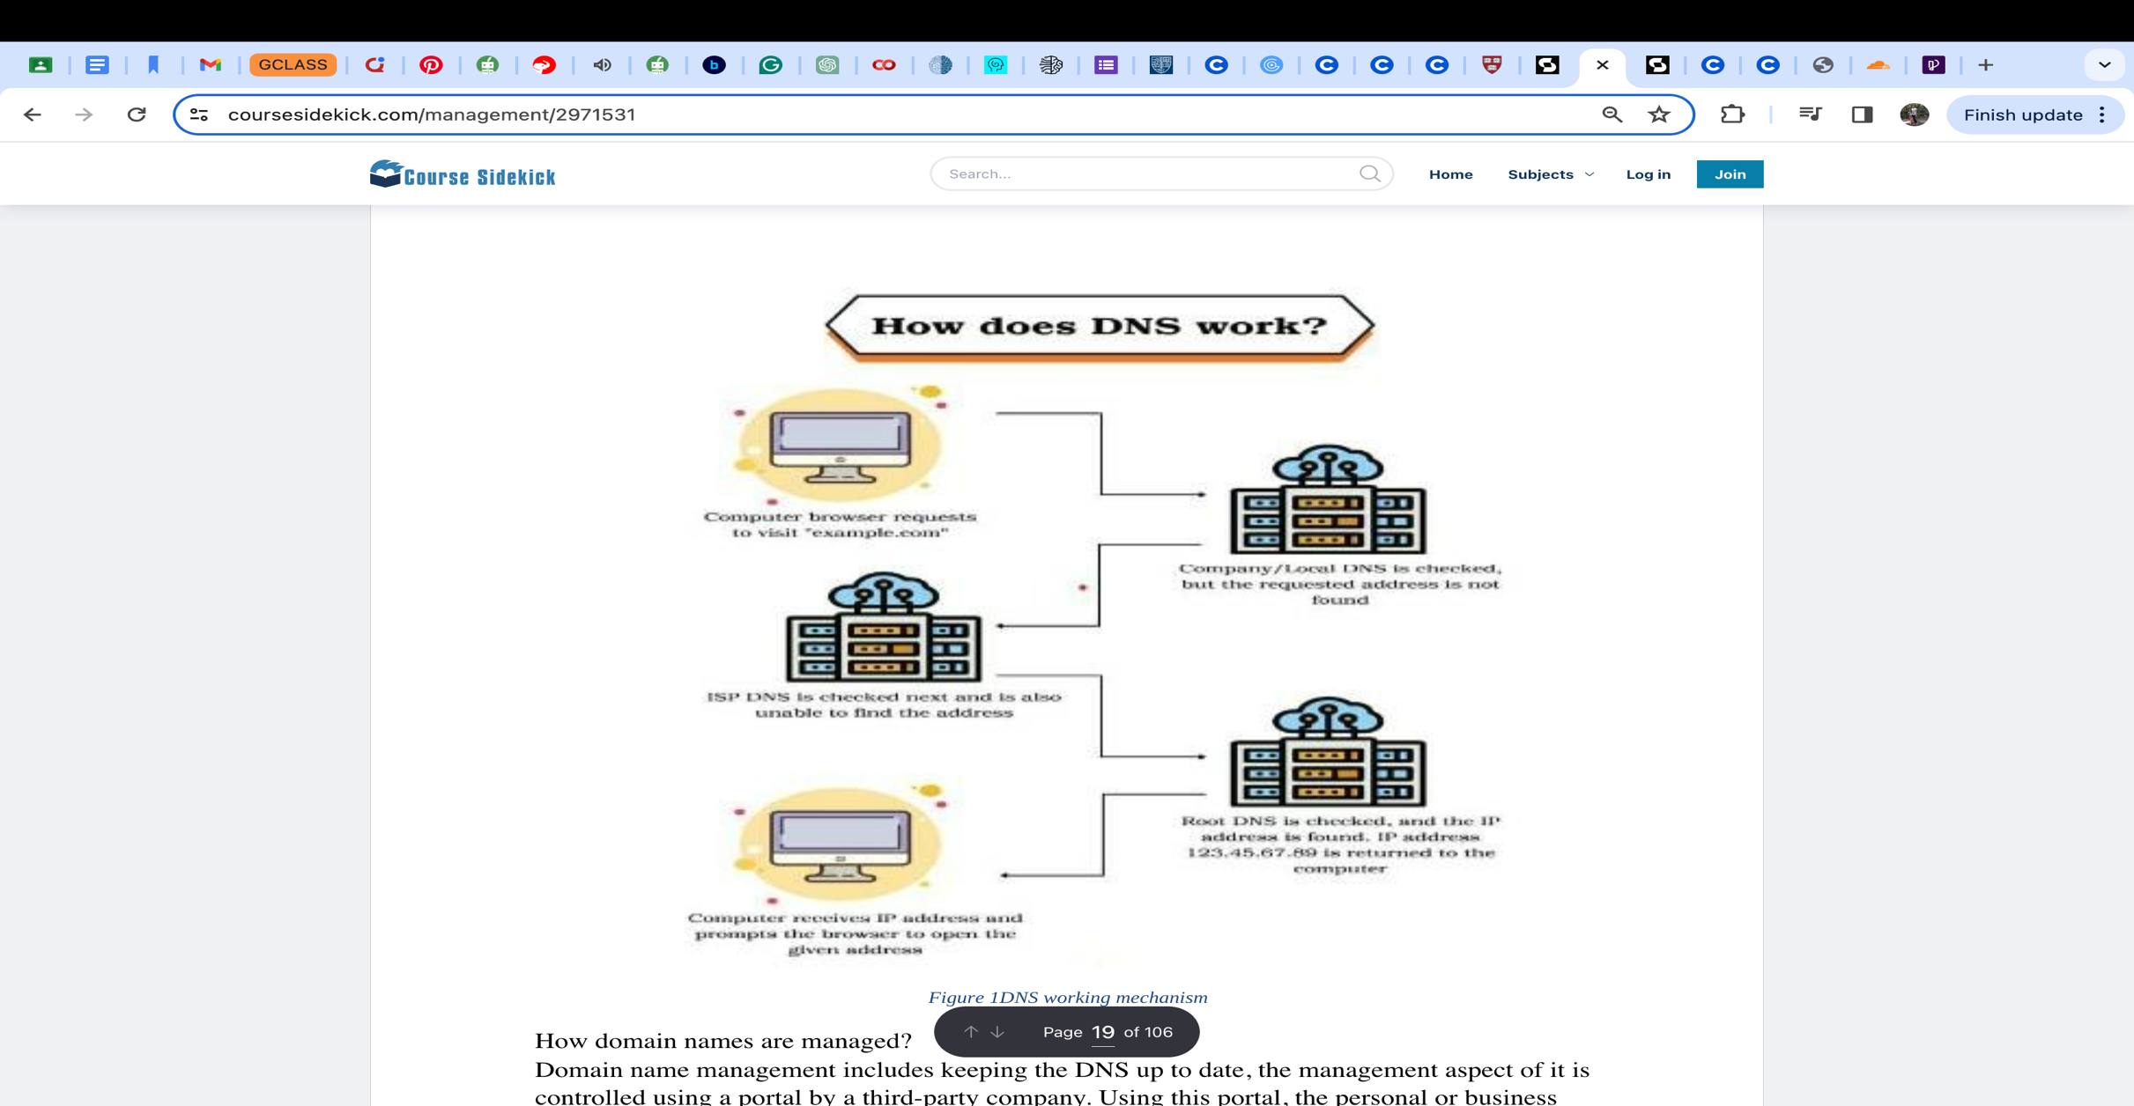

Domain name management includes keeping the DNS up to date, the management aspect of it is controlled using a portal by a third-party company. Using this portal, the personal or business website can control DNS records which allow access to the website, your blog, email, and other online assets. Lots of companies online offer services that will control your domain names for you, these will keep your domain name from expiring by offering an auto-renewal service with their service. Once your domain name is up and running you can then use the portal to manage your domain and all aspects of it easily from one place, you can change the DNS records quickly and easily for different domains.

**Explain the purpose and relationships between communication protocols, server hardware operating systems, and web server software with regard to designing, publishing, and accessing a website.**

### 1.2.1 What are Communication Protocols?

**Communication Protocols Used to Access a Website:**

Hypertext Transfer Protocol (HTTP):

Hyper Text Transfer Protocol is the foundation of the World Wide Web, used to load webpages using hypertext links. It is designed to transfer information between networking devices and servers, specifying how said servers and browsers react with one another, as well as showcasing the formatting of messages and the response of the system to different commands, usually operating on port 80 on TCP/IP.

Hyper Text Transfer Protocol Secure (HTTPS):

HTTPS, on the other hand, is an extension of the above, which includes SSL/TLS encryption for secure data transfer. It encrypts data like passwords, and payment details, ensuring confidentiality and security, usually operating on port 443 on TCP/IP. It’s a secure protocol that encrypts the data that is being sent over the website that it is on. It does so by exchanging keys with the customer and the website so that if it is intercepted and stolen it cannot be decrypted unless they have the keys from the owner and customer.

File Transfer Protocol (FTP):

FTP is mainly a standard protocol of a Network that is used to transfer data from client to host or one server to another server, it uses a client-server architecture. When creating a website, you will use the FTP protocol to upload your created and completed web pages to the web server, this is normally done through the FTP protocol using a program such as FileZilla. The port numbers used by this are 20 for data and 21 for control.

Simple Mail Transfer Protocol (SMTP):

The mail protocol uses the SMTP protocol to send emails on the internet, it only sends the mail from one user to another. To receive the emails, then the POP3 protocol is used to collect the mail from the receiver. This protocol works with the Mail Transfer Agent (MTA) protocol to send your communication to the correct computer and email inbox. The port number used by SMTP is 25.

Transmission Control Protocol (TCP):

TCP is a connection-oriented program that ensures the transfer of data between client and server in a reliable manner. Initially establishing a connection, it then proceeds to handle data integrity and order. TCP is the backbone of the HTTP and HTTPS traffic.

Internet Protocol (IP):

IP transfers data packets across networks, using addresses like IPv6 and IPv4, directing data to their respective destinations based on their IP addresses, and helping clients find their required server.

Secure Socket Layer/Transport Layer Security (SSL/TLS):

SSL/TSL protocols secure internet connections with encryption as well as authentication. They establish secure and safe connections, ensuring the confidentiality and completeness of data.

#### Purpose of CP

Communication protocols are the fundamental mechanisms for data interchange between clients and servers, providing common languages and rules for the passage of web resources from one end to the other.

**- Designing:** In the design stage, communication protocols are chosen and configured with great care to support the expected number of users and interactions, laying down a flexible groundwork for efficient data transfer and communication within the architecture of the web site.

**- Publishing:** In the publishing stage, communication protocols facilitate the publishing of web sites by allowing browsers to request and retrieve web pages, guaranteeing that users reach the content they need reliably and securely.

**- Accessing:** In the interaction stage between users and the website, communication protocols govern the transfer of data and messages between clients and servers, with much efficiency and little latency ensuring the pleasurable browsing experience.

#### Relationships of CP:

* Communicates closely with the web server software that will process incoming requests and generate responses.
* Depends on the hardware of the server and the operating systems, which guarantee reliable transmission and reception of data packets.
* Influences user experience by determining the efficiency and speed of data transfer in accessing the website.

### 1.2.2. What are Server Technologies?

Operating System**:**

OS manages server resources and supports application execution, consisting of web server software. A few instances would be Linux distributions (e.g., Ubuntu Server, CentOS, Debian) and Windows Server.

Web Servers:

Web servers host and serve web content and respond to HTTPS/HTTPS requests including Apache, Nginx, Microsoft Internet Information Services (IIS), and LiteSpeed.

Application Servers:

Application servers, on the other hand, handle business logic while processing dynamic content (e.g., PHP, Python, Ruby) on the server side. They work alongside web servers to process content dynamically.

Database Servers:

Database servers control the storage, management, and retrieval of data for websites and applications. Examples include MySQL, PostgreSQL, MongoDB, and Redis.

Virtualization and Containerization:

Virtualization (e.g., VMware, HyperV) allows multiple virtual servers on a single physical machine. Containerization (e.g., Docker, Kubernetes) provides isolation for applications.

Cloud Computing Platforms:

Cloud platforms (e.g., AWS, Azure, Google Cloud) offer scalable server infrastructures on demand. They provide services such as virtual machines, storage, databases, etc.

Networking Technologies:

Networking components (e.g., routers, switches, firewalls) ensure proper data flow and security. Advanced networking protocols (e.g., SDWAN) improve connectivity and traffic management.

#### Purpose of Server Technologies

Server hardware is the physical basis for hosting a website, as it provides the infrastructure for storing, processing, and delivering web content to users worldwide.

- Designing: During the design stage, specifications on server hardware are carefully assessed and chosen based on features like processing power, memory capacity, and storage space for meeting the performance and scalability needs of the intended website.

- Publishing: After being configured, server hardware plays a crucial role in website publishing, ensuring their availability and responsiveness by efficiently handling incoming requests and delivering the content to the users within the shortest possible time.

- Accessing: From a user's standpoint, server hardware influences the accessibility and responsiveness of websites, since robust hardware configurations ensure the pleasurable browsing experience through minimization of downtime and latency.

#### Relationships of Server Technologies

Dependent on operating systems to efficient management of the hardware resources and the proper allocation of these resources to web server software.

Affects the choice of web server software depending on its compatibility and optimized performance for the hardware specs.

Directly affects website availability and reliability depending on hardware capabilities and configuration.

### 1.2.3. Web Server Software

Web server software is an application used to serve web content to clients across the internet. Usually, this is the web browser, though it may be a client-based application. Web server software is used to deal with incoming requests on the HTTP protocol and process them dynamically if necessary before sending back web pages, files, or applications to the client. Some examples of web server software include the Apache HTTP Server, Nginx, Microsoft Internet Information Services, and LiteSpeed Web Server. These provide a platform for hosting websites and ensuring smooth communication between web users and web resources.

Examples:

* Apache HTTP Server: Opensource, a widely used web server.
* Nginx: High performance, lightweight web server and reverse proxy.
* Microsoft Internet Information Services (IIS): Web server software for Windows servers.
* LiteSpeed: High-performance web server with caching and security features.

#### Purpose of Web Server Software

Web server software acts as a middleman between client and the server so as to receive requests, generate dynamic content, and deliver web pages to the browsers of the client user.

**-Designing:** A developer must opt for proper web server software at the design stage for a website. It is not only required to meet the requirements of functionality and performance to scale but these requirements must also be customized for client needs. It will ensure a smooth delivery of the content to the clients.

**-Publishing**: During deployment, web server software is to publish the websites by receiving requests, processing content, and providing the responses to the users. The website will ensure proper access to the web resources.

**-Accessing**: During user interaction phase, web server software makes user accessing hassle-free because it is to receive the HTTP requests, process it, and send the content to the user's browser so that they may browse in a hassle-free manner.

#### Relationships of Web Server Software

It requires communication protocols so as to send and receive the HTTP requests and responses between the clients and the server.

It works together with the operating system so as to make optimal use of the system resources and reliably maintain performance.

It determines the accessibility and the functionality of the website because the server is to receive the users' requests and deliver the content efficiently.

### 1.2.4. Operating Systems

An operating system is the most basic software support that runs applications on a server through an environment, where hardware resources are managed through process scheduling, memory management, and device control. The choice of an OS for hosting a web site will influence the stability and security of the server as well as its compatibility with web server software and applications. The common operating systems used as a web server are Linux-based distributions such as Ubuntu and CentOS and Windows Server. These operating systems will run efficiently in the backbone of the web server, and resources will be used appropriately.

#### Purpose of OS

Operating systems are the software platform and server management base that provides the necessary tools and resources to properly control the hardware components and run web server software appropriately.

**-Designing**: During the design process, operating systems are selected and properly configured for a stable and safe platform to host websites, and compatibility with web server software is ensured and also efficient resource usage is provided.

**-Publishing**: Operating systems have a crucial role in the publishing process by running web server software with a runtime environment in which web content may be served to the users. Operating systems make it easier to deploy and run websites.

**-Accessing:** Operating systems are in charge in the accessing process by determining how to interact with websites and optimizing performance and security by efficient resource management and proper process execution.

#### Relationships of OS

Works closely with the web server software to provide an environment for runtime stability and security when hosting websites.

Influences the choice of server hardware depending on the compatibility and optimization for specific operating system distributions.

It affects website accessibility and performance by efficient management of resources and proper process execution.

### 1.3. Analyse the impact of common web development  technologies and frameworks with regard to website design, functionality and management.

### 1.3.1. Website Design

* Responsive Design Toolkits: Frameworks like Bootstrap smoothen the road for creating websites that adjust seamlessly to different display dimensions, enriching user experiences across a range of machines.
* CSS Compilers: SASS and LESS allow developers to streamline and utilize styling techniques for efficient upkeep of dynamic data and easier updates to ensure sustainability.
* JavaScript Libraries: Tools such as jQuery make tasks like tweaking the DOM and handling events a breeze, paving the way for impressive and interactive web designs.
* Version Control Systems: Platforms like GitHub, GitLab, and Bitbucket which host the version histories of the code and enable collaborative development are very important. They provide a scalable way for coding, as well as tools for change tracking and branch management.
* Security Protocols: The comprehensive use of SSL/TLS certificates coupled with secure coding practices plays a central role in keeping the website secure from cyber attacks. Technologies such as Web Application Firewalls (WAFs) also act as additional shields against cyber threats.

### 1.3.2. Website Functionality

* JavaScript Frameworks: React and Angular provide a strong footing for beginners in the developing field to craft lively web apps with smooth data management and top notch rendering.
* ServerSide Frameworks: Express.js (Node.js) and Django (Python) offer a robust base for creating scalable serverside systems that support complex features.
* API and Web Service Integrations: Merging with APIs and external web services allows websites to provide advanced features like geolocation, payment processing, and access to external data.
* Progressive Web Apps (PWAs): PWAs incorporate the advantage of both web and mobile applications offering offline services, fast loading times, and app-like user experience.
* ThirdParty Integrations: Integrating with services such as payment gateways, social media platforms, and various APIs, improves the website’s functionality and makes it attractive to a wide range of clients.

### 1.3.3. Website Management

* Content Management Platforms: Systems such as WordPress and Drupal allow easy control over website content, enabling well-performing updates even for those who aren't code-savvy.
* Version Control Repositories: Git facilitates joint development and collaboration, enabling teams to efficiently oversee code changes and maintain a tidy history of project updates.
* Deployment Utilities: Docker and Kubernetes offer smooth deployment processes, ensuring consistent and scalable environments across development stages.
* Motion Design and Animations: CSS animations and libraries of GSAP are the tools that are used for creating smooth transitions and movements in order to facilitate satisfactory user engagement and experiences.
* Web Fonts and Typography: Google Fonts and Adobe Fonts Web font packages utilize a wide range of typefaces that provide the website with a better user impression.

These technologies and frameworks play a vital role in web development projects, enhancing user experiences and making websites easier to manage over time.

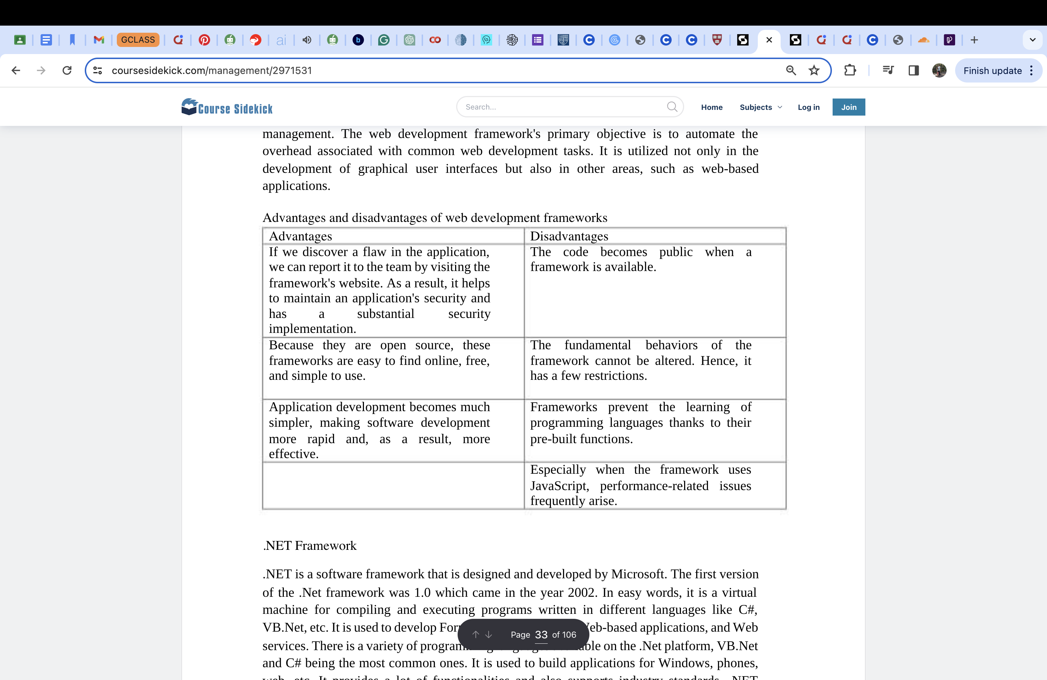

**Review the influence of search engines on website  performance and provide  evidencebased support for  improving a site’s index  value and rank through  search engine optimisation.**

### 1.4.1. What is Search engine optimization (SEO)?

▪ The art and science of search engine optimization (SEO) involves raising a page's search engine ranking in Google and other search engines. A website's traffic may rise as a result of ranking better in search results as this is one of the primary ways users find material online.

▪ The results page in Google and other search engines frequently has sponsored advertisements at the top of the page, followed by the standard results, or what search marketers refer to as the "organic search results." To distinguish it from traffic obtained through sponsored search, traffic obtained through SEO is frequently referred to as "organic search traffic." Pay-per-click (PPC) and search engine marketing (SEM) are other names for paid search (PPC).

Search engines take a lead in determining which websites will be able to feature on the World Wide Web and be exposed to the millions of surfers searching for information on the Internet. There is no such system of listing that can expose websites like social media where almost all people who come online do so on mobile phones. Therefore, those who perform well in search engine results pages (SERPs) are more likely to gain organic traffic, which translates to better visibility, credibility, and any corresponding monetization opportunities. Websites can engage effective SEO strategies to help them improve their index value and rank to have them better shown by search engines.

As we know today, that the huge content of the internet has made it difficult to find relevant information on a particular subject. So finding methods to improve the retrieved information has become very important nowadays. Hence the search engine becomes an integral part in everyones life to search information. So we rely on search engines to provide right information at right time. Search engines must satisfy the users by finding and filtering the most relevant information matching the search term given by the user and displaying that information. Major search engines like Google rely on page relevancy and page importance for ranking the pages of a website or the overall website.

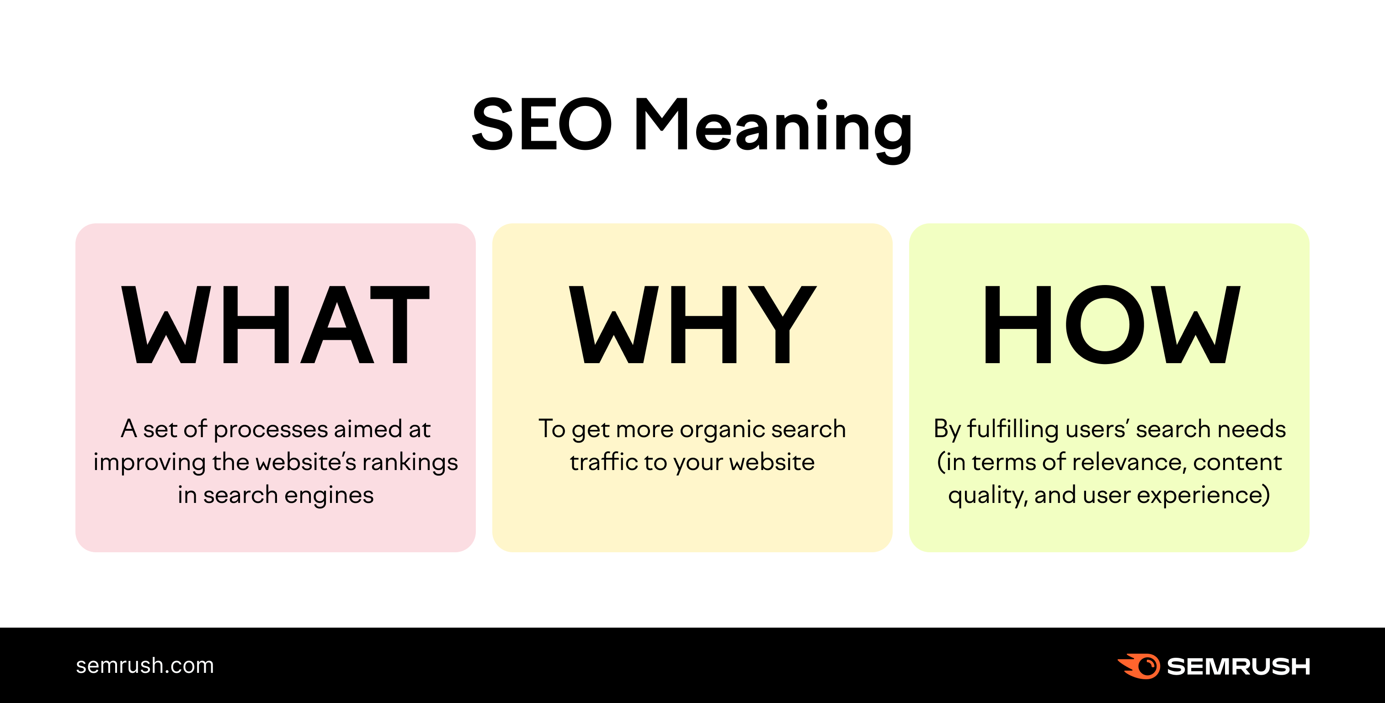

Search engines like Google and Bing utilize bots to move between websites, acquire information about them, and index them in order to crawl internet pages. Think of the index as a massive library where a librarian might quickly call up a particular book (or web page) to help people find it.

The algorithms that look at sites in the index while taking into account thousands of ranking factors or signals then decide in what order pages should show in the search results for a certain query. The librarian in our imagined library has read every book there and knows which one would offer the answers to our issues. We may consider the various user experience components to be substitutes for our SEO success factors. This is how search engine bots evaluate how well a website or web page can deliver the results a user is looking for. Unlike paid search advertising, greater organic search rankings cannot be purchased, thus SEO experts must put in the required work.

For each query, search engines like Google utilize an algorithm or set of rules to decide

which sites to display. To decide the ranks of their SERPs, these algorithms, which have

become incredibly complicated over time, consider hundreds or even thousands of

distinct ranking indicators. Search engines, however, base their evaluation of a site's

quality and where it should rank on three key metrics:

Links: The ranking of a website in Google and other search engines is significantly

influenced by links from other websites. Due to the fact that website owners are unlikely

to link to low-quality websites, a link can be viewed as a vote of approval from other

websites. In the view of search engines, websites that receive links from several other

websites gain authority (referred to as "PageRank" by Google), particularly if the

websites linked to them are also authoritative.

Content: Search engines examine a webpage's content in addition to its links to evaluate

if it would be relevant for a particular search query. Making content that is focused on the

keywords that users of search engines are looking for is a big aspect of SEO.

Page structure: Page structure makes up the third essential element of SEO. Because

HTML is the language used to create webpages, the way the HTML code is organized can

affect how well a search engine understands a page. Site owners may take steps to

enhance the SEO of their website by include pertinent keywords in the page's title, URL,

and headers and by ensuring that a site is crawlable.

In our Periodic Table of SEO Factors, the criteria are divided into six main groups and given weights depending on their relative importance to SEO. For instance, although content quality and keyword research are essential elements of content optimization, crawlability and speed are significant site design characteristics. The freshly updated SEO Periodic Table also includes a list of Toxins that impair SEO best practices. These are shortened versions of techniques or methods that, in the past, when search engine algorithms were less complex, would have been enough to guarantee a high rank. They could even just momentarily work right now. We also have a new niches section where we go into great detail on the SEO success criteria for three key topics: local SEO, news/publishing, and e-commerce SEO. Even while our basic SEO Periodic Table will provide you the best practices, knowing the nuances of SEO for each of these Niches will help us succeed in search results for a small business, food blog, and/or online store. The goal of the search algorithms is to provide consumers with an effective search experience by surfacing reliable, relevant pages. If we optimize our site and content with these factors in mind, our pages could rank higher in the search results.

For each query, search engines like Google utilize an algorithm or set of rules to decide

which sites to display. To decide the ranks of their SERPs, these algorithms, which have

become incredibly complicated over time, consider hundreds or even thousands of

distinct ranking indicators. Search engines, however, base their evaluation of a site's

quality and where it should rank on three key metrics:

Links: The ranking of a website in Google and other search engines is significantly

influenced by links from other websites. Due to the fact that website owners are unlikely

to link to low-quality websites, a link can be viewed as a vote of approval from other

websites. In the view of search engines, websites that receive links from several other

websites gain authority (referred to as "PageRank" by Google), particularly if the

websites linked to them are also authoritative.

Content: Search engines examine a webpage's content in addition to its links to evaluate

if it would be relevant for a particular search query. Making content that is focused on the

keywords that users of search engines are looking for is a big aspect of SEO.

Page structure: Page structure makes up the third essential element of SEO. Because

HTML is the language used to create webpages, the way the HTML code is organized can

affect how well a search engine understands a page. Site owners may take steps to

enhance the SEO of their website by include pertinent keywords in the page's title, URL,

and headers and by ensuring that a site is crawlable.

For each query, search engines like Google utilize an algorithm or set of rules to decide which sites to display. To decide the ranks of their SERPs, these algorithms, which have become incredibly complicated over time, consider hundreds or even thousands of distinct ranking indicators. Search engines, however, base their evaluation of a site's quality and where it should rank on three key metrics:

Links: The ranking of a website in Google and other search engines is significantly influenced by links from other websites. Due to the fact that website owners are unlikely to link to low-quality websites, a link can be viewed as a vote of approval from other websites. In the view of search engines, websites that receive links from several other websites gain authority (referred to as "PageRank" by Google), particularly if the websites linked to them are also authoritative.

Content: Search engines examine a webpage's content in addition to its links to evaluate if it would be relevant for a particular search query. Making content that is focused on the keywords that users of search engines are looking for is a big aspect of SEO.

Page structure: Page structure makes up the third essential element of SEO. Because HTML is the language used to create webpages, the way the HTML code is organized can affect how well a search engine understands a page. Site owners may take steps to enhance the SEO of their website by include pertinent keywords in the page's title, URL, and headers and by ensuring that a site is crawlable.

Higher the Page Rank (PR) value, more popular the website is. Many strategies are used by website designers to score a higher rank in search engine results. Search Engine Optimization (SEO) is the activity of optimizing individual web pages or the entire website to acquire higher ranking in search results. Search Engine Optimization (SEO) improves the quality and volume of traffic to a site utilizing targeted keywords. There are multiple types of Search Engines to be found on the web. Below stated are a few:

* General SEs: e.g. Google, Yahoo, Bing, Ask etc.
* Vertical Search SEs: It focuses mainly on specific resources and reduces the number of irrelevant hits.

E.g. Travelocity and Expedia.

* Location Based SEs: They use geographical information such as, IP addresses and zip codes, about the users to get more relevant results.

Search engines not only provide convenience for users in gathering useful information, but it is also an effective tool for understanding web users behavior. Efficient search engine allows users to find the relevant target information quickly and accurately. Search engine optimization relates to the activity of improving the ranking of individual webpages or the website to get higher position in the search results. The SEO technique entails two processes: onsite optimization and offsite optimization. Onsite optimization are the practices which are used during the development of a website. Offsite optimization are the practices through which the contents of a website are propagated over the Internet to increase its traffic which in turn helps enhance ranking of the website.

**Impact on Website Performance**:

Search engines affect the performance of websites in many ways:

1. Traffic Generation: Websites that rank well on search results get more organic traffic. Users generally click on the first page links and usually pay attention to the first three results. Higher rankings can increase visibility and subsequently lead to a better user engagement for the site.

2. User Experience: Search engines look for positive user experiences among websites. Things that influence a good user experience include quicker loading times, friendliness to mobile devices, and good navigation.

3. Brand Reputation and Trust: Highly ranking websites can often be taken as more trusted and reliable. Google, for example, may give better rankings to the sites it believes are of better quality and value.

**Search engine optimization techniques.**

Keyword research - Keyword research is often the starting point for SEO and involves looking at what keywords a site is already ranking for, what keywords competitors rank for, and what other keywords potential customers are searching for. Identifying the terms that searchers use in Google search and other search engines provide direction on what existing content can be optimized and what new content can be created.

Content marketing - Once potential keywords are identified, content marketing comes into play. This can be updating existing content or creating brand new pieces of content. Because Google and other search engines place a premium on high-quality content, it's important to research what content is already out there and create a compelling piece of content that provides a positive user experience and has a chance of ranking higher in the search engine results. Good content also has a greater chance of being shared on social media and attracting links.

Link building - Because links from external websites (called "backlinks" in SEO parlance) are one of the core ranking factors in Google and other major search engines, obtaining high-quality backlinks is one of the main levers that SEO has. This can involve promoting good content, reaching out to other websites and building relationships with webmasters, submitting websites to relevant web directories, and getting press to attract links from other websites.

On-page optimization - In addition to off-page factors such as links, improving the actual structure of the page can have tremendous benefits for SEO, and is a factor that is entirely in the control of the webmaster. Common on-page optimization techniques include optimizing the URL of the page to incorporate keywords, updating the title tag of the page to use relevant search terms, and using the alt attribute to describe images. Updating a page's meta tags (such as the meta description tag) can also be beneficial-- these tags don't have a direct impact on search rankings but can increase click-through rate from the SERPs.

Site architecture optimization - External links are not the only thing that matters for SEO, internal links (the links within one's own website) play a large role in SEO as well. Thus, a search engine optimizer can improve a site's SEO by making sure key pages are being linked to and that relevant anchor text is being used in those links to help improve a page's relevance for specific terms. Creating an XML sitemap can also be a good way for larger pages to help search engines discover and crawl all of the site's pages.

Semantic markup - Another SEO strategy that SEO experts utilize is optimizing a website's semantic markup. Semantic markup (such as Schema.org) is used to describe the meaning behind the content on a page, such as helping to identify who the author of a piece of content is or the topic and type of content on a page. Using semantic markup can help with getting rich snippets displayed in the search results page, such as extra text, review stars and even images. Rich snippets in the SERPs doesn't have an impact on search rankings, but can improve CTR from search, resulting in an increase in organic traffic.

**SEO Ranking Factors**

Keyword Research: Keyword Research is the process of finding the actual search terms that people are entering into the search engines. Its helps in acquiring and maintaining the attention of your correct audience, as well. Effective Keyword Research gets more benefits such as engagement of correct audience, increase in customer conversion, increase SERPs Position, and more.

URL Optimization: Website URL structure should be short and keyword rich; Dynamic URL's structure should be avoided. First, 3 to 5 words in a URL structure is more important as it contributes more weight to the website. Using keywords in a URL can be referred as one of the best practices. Proper structuring of URL with specific keywords will definitely give you a good page rank in search engines like Google and others.

Meta Tags: Meta Tags is the most important factor of On Page SEO. It has four fundamental components: Meta Title, Meta Description, Meta Keywords, and Meta Robots Tag. While the Meta Title is used to describe or convey the contents of a page on to the search engines and users, Meta Description is a short description that tells the search engines and users about page concepts. Meta Robots is a tag that tells the search to follow a specific page in the website, and Meta Keywords describe the list of keywords and their relevance.

Header Tags: Header Tags are pieces of HTML Code that allow us to make certain keywords stand out on a web page. It tells the user what the page is about and also determine whether continue to read it or not. It also helps to improve search engine placement.

Content Optimization: Content is the king! Professional Content Optimization focuses on using specific keywords in very specific places to send the strongest and high ranking for keyword target. It encourages the website owners to get top SERPs Rankings. Keyword frequency, relevance, usefulness, and progression are some of the important things to consider under Content Optimization.

**Justify the technologies,  management services, tools and  software chosen to realise a  custom-built website.**

### 1.5.1. What is the Front-End?

The front end of a website is where users can interact directly. The front end's primary goals are responsiveness and performance. On the other hand, the back end of the website is where different kinds of code are run on the server and where data is managed. The back end is referred to as the server side, and the front end is referred to as the client side. The website's responsiveness must be ensured by developers on the front end. The website needs to look good on all devices, no matter how big the screen is. There are very few front-end programming languages. HTML, CSS, and JS are the front-end languages. PHP, C++, C#, Python, .Net, Ruby, and other languages are the back-end programming languages that are used the most. The data needed to host the website is stored on the server side of the website. The back-end makes it possible for the server, application, and database to walk hand in hand.

 In layman's terms, a website's front end is what happens in front of users. A browser, for instance, will display precisely what the user has searched for. It includes not only what the users searched for but also the entire website architecture that they see on their devices. Websites use HTML to include content, CSS to style HTML-based content, and JS to create events to improve the user experience (UX). These coding standards are used to create the pages on the websites. They are then styled in accordance with the client's instructions. Websites can also be made by web developers using only front-end coding. Static websites are the resulting websites. These websites are used to display information that does not require constant updating and can only run on the local machine.

Back-end consists of the server which provides data on request, the application that channels it, and the database which organizes the information. The back end is in charge of storing and organizing the data that ensures the website's client side runs smoothly. Users are unable to view or interact with it because it is a component of the website. The front end is necessary for the back-end coding. We can't make a website with only the backend, unlike with the front end. Through the front-end application, users can access the back-end indirectly. The website's database is also handled directly by the backend. A website's database is crucial for storing data necessary for website development. MySQL, PhpMyAdmin, and other databases are commonly utilized. In addition to facilitating the events that are requested by the front end in relation to the database, the back end is in charge of the codes that are related to the data's security. The back-end is in charge of protecting the data and sensitive information. Clients must be signed in utilizing the HTTPS convention. Any website that uses a user's login and other personal information must also use the HTTPS protocol.

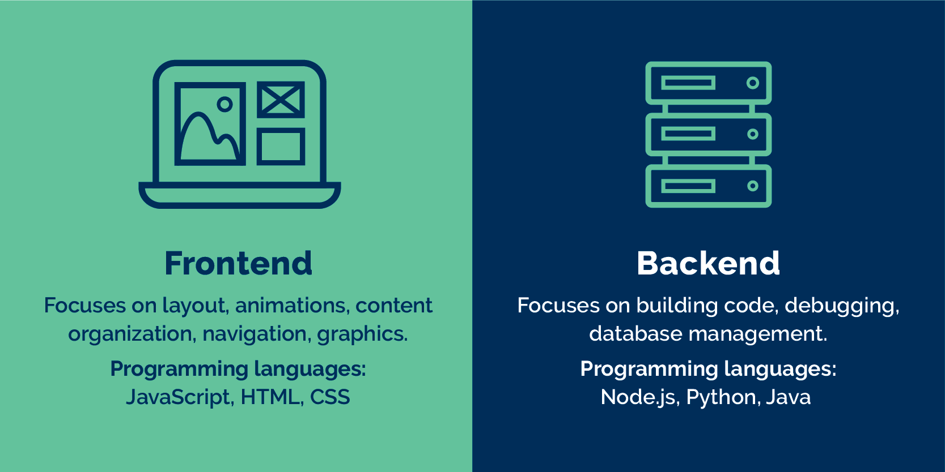

### 1.5.2. What is the Application Layer?

The front end of the website makes use of the application layer of the OSI model. This layer contains the utilitarian business rationale that drives the center abilities of the application. Through back-end languages like Java, Python, C+ +, C#, and so on, we can observe how the application layer is applied in the front end. The FTP protocol is used to transfer files between the server and the client in the application layer. The interface between the application and the network is provided by the application layer. It has to do with the person using the computer. Numerous protocols like DNS, SMTP, and Telnet are utilized in this layer. On the internet, the SMTP protocol is used to send emails, and the POP3 protocol is used to receive emails. Remote access to a device is made possible by Telnet protocols.

### 1.5.3. What is the Presentation Layer?

The OSI model's presentation layer is in charge of data translation, encryption, and compression. The technology that powers the presentation layer is called the back-end. The user interface and the back-end are connected by means of HTML, CSS, and JS. When data passes through the HTTPS protocol, it is encrypted to protect it from being intercepted by hackers during transmission. During the transmission, the two gatherings will trade keys to encode the information. As a result, only the content can be decrypted by the two parties. The hacker cannot access meaningful data if the data is intercepted during transmission.

### 1.5.4. Web-based Technologies

1. HTML/CSS/JavaScript: These fundamental web technologies are used for the creation of the structure, styling, and interactivity of web pages. HTML specifies the content and structure, CSS offers the visual presentation, and JavaScript provides dynamic behavior and interactivity. For instance, HTML5 introduces new semantic elements such as <header>, <footer>, and <nav>. On the other hand, CSS3 introduces advanced styling features, which include animations and gradients. JavaScript frameworks such as React.js and Vue.js standardize the development process in a way that developers can reuse the components and manage the state.

2. Backend Frameworks: Backend frameworks like Node.js, Django, and Ruby on Rails support server-side development and fulfill tasks like data processing, authentication, and routing. For example, Node.js makes server-side JavaScript runnable, and Django makes Python-based web development quite easy with its built-in ORM and templating features.

3. Database Systems: Database systems like MySQL, MongoDB, and PostgreSQL are used for storing and retrieving data from web applications. MySQL is a very well-known RDBMS that is reliable and scalable, whereas MongoDB is a NoSQL database that is flexible and scalable in terms of allowing for the existence of unstructured data.

### 1.5.5. Management Services

1. Version Control Systems (e.g., Git): Version control systems are imperative in the context of being able to manage changes in code and coordinating work with team members. Git alongside platforms like GitHub and GitLab allows developers to track code changes among multiple contributors, merge codes, and even roll back to previous versions if necessary.

2. Project Management Tools (e.g., Jira, Trello): Project management tools allow developers to organize tasks, track progress, and coordinate team activities. Jira can be used for project management in issues related to projects, agile project management, and team collaboration. Whereas Trello offers a more visual way of using a Kanban-style board to manage tasks and projects.

3. Continuous Integration/Continuous Deployment (CI/CD) Tools (Jenkins, Travis CI): CI/CD tools automate the process of building, testing, and deploying code changes. Jenkins lets developers automate the entire software delivery pipelineᅳcode integration and tests to deploying. Travis CI is a cloud-based CI/CD service for automating builds and tests.

### 1.5.6. Tools and Software

1. Code Editors/IDEs (Visual Studio Code, IntelliJ IDEA): Code editors and Integrated Development Environments include support for code writing, editing, and debugging. Visual Studio Code is a very lightweight, but powerful code editor that has built-in support for many programming languages and extensions. IntelliJ IDEA is a feature-rich IDE designed especially for Java development.

2. Web Development Frameworks (Bootstrap, Materialize): Web development frameworks like Bootstrap and Materialize provide pre-designed UI components and CSS stylesheets to make frontend development easier. Bootstrap is an open-source front-end framework for creating responsive, mobile-friendly sites using a grid system, typography, and components such as buttons and forms.

3. Performance Monitoring and Optimization Tools (Google PageSpeed Insights, GTmetrix): Performance monitoring and optimization tools let you find and fix performance problems in web applications. Google PageSpeed Insights provides a look at the performance of web pages by analyzing load times and then provides suggestions for things to improve. GTmetrix provides in-depth reports of page speed, YSlow score, and performance insights.

### 1.5.7. Building a Website

These include technologies, management services, tools, and software that would be fused to create a well-structured, cohesive development workflow for web development. Frontend structure, styling, and interactivity are covered by the trifecta HTML/CSS/JavaScript. The backend frameworks and database systems take care of the logic in the server and management of data. Version control systems, project management tools, and CI/CD tools play their part in collaboration, tasks, and automated deployment. Code editors/IDEs, web development frameworks, and performance optimization tools streamline the development process and ensure the website is of high quality in terms of performance and usability. This way, through the proper use of these resources, a developer can create a robust, scalable, and user-friendly website that caters to the needs of their target audience.

Custom Built Website vs Template Website

KEY WORDS CUSTOM BUILT WEBSITE TEMPLATE WEBSITE

1.Cost High initial realization costs Low initial cost

2.Maintenance to guarantee responsiveness and security, need to maintain a team of

professionals to monitor and improve the website Maintenance involves only texts and

pictures, so it does not need information technology professionals

3.Construction Time a custom-made website may take from a few weeks to a few

months to be built, depending on its complexity short construction time

4.Securityif updated constantly, custom-made websites are more secure than template

sites Low security

5.User experience Offer higher satisfaction and better user experience Templates are

basic in design with navigational limitations with average user experience

## **2. Categorise website technologies, used to  develop websites.**

### 2.1.1. About Frontend

The front end of a website is the section that the user interacts with directly. It's also referred to as the application's 'client side.' Everything that users see directly is included: text colors and styles, photos, graphs and tables, buttons, colors, and the navigation menu. The languages used for Front End development are HTML, CSS, and JavaScript. Front-end developers provide the structure, appearance, behavior, and content of everything that appears on browser displays when websites, web applications, or mobile apps are opened. The Front End's major objectives are responsiveness and performance. The developer must guarantee that the site is responsive, meaning that it works properly on devices of all sizes. No part of the website should behave abnormally irrespective of screen size.

### 2.1.2. Frontend Development:

The front end of a website refers to the area that users interact with directly. It is sometimes referred to as the application's "client side." It covers everything that users see and interact with immediately, such as button colours, text styles, photos, graphs, and tables. For front-end development, three languages are used: HTML, CSS, and JavaScript. Front end developers put into practice the structure, design, behaviour, and content of everything seen on browser displays when websites, web applications, or mobile apps are opened. The Front End's primary goals are responsiveness and performance. The website's developer must make sure that it is responsive, meaning that it displays properly on all types of devices and shouldn't act strangely depending on the size of the screen.

### 2.1.3. Frontend Development Languages

### 

Hypertext Markup Language (HTML): HTML stands for Hypertext Markup Language. It is a markup language that is used to design the front-end portion of web pages. HTML combines hypertext with markup. The term "hypertext" refers to the link between web pages. Within the tag that specifies the structure of web pages, the markup language is used to create the text documentation.

CSS: CSS stands for Cascading Style Sheets, which is a simple language meant to make the process of making web pages presentable easier. Styles can be applied to web pages using CSS. More crucially, CSS allows you to do so without having to worry about the HTML code that makes up each web page.

JavaScript: JavaScript is a well-known programming language that is used to create magic on websites in order to make them more interactive for users. It's utilized to improve a website's functionality and run exciting games and web-based software.

React: JavaScript is used to create the UI development library React. It is controlled by Facebook and an open-source development community. Despite being a library and not a language, react is widely used in web development. One of the most used frontend frameworks for web development, the library was released in May 2013.

jQuery: A popular and well-known JavaScript framework and application development environment is jQuery. It has characteristics that make the job of a JavaScript application developer much easier and is smaller, faster to load, and filled with functionality. JavaScript is no longer grafted onto stateless HTML as an afterthought. From PCs to tablets and smartphones, it is increasingly employed as the basis and the main engine for web development and application development.

### 2.1.4. What is Backend?

The server-side of a website is called the backend. It also ensures that everything on the client side of the website functions properly while storing and organizing data. It is the portion of the website that you are unable to view and use. It is the part of the program that consumers do not directly interact with. Users indirectly access the components and features created by backend designers through a front-end application. The backend also includes tasks like writing APIs, building libraries, and interacting with system elements devoid of user interfaces or even systems of scientific programming.

### 2.1.5. Backend Development

The server-side of a website is called the backend. It also ensures that everything on the client side of the website functions properly while storing and organizing data. It is the portion of the website that you are unable to view and use. It is the part of the program that consumers do not directly interact with. Users indirectly access the components and features created by backend designers through a front-end application. The backend also includes tasks like writing APIs, building libraries, and interacting with system elements devoid of user interfaces or even systems of scientific programming.

### 2.1.6. Backend Development Languages

### 

PHP: The server-side scripting language PHP was created primarily for building websites. PHP is referred to be a server-side scripting language since it executes code on the server. C++: It is a general-purpose programming language that is frequently used in modern programming competitions. In addition, it serves as a backend language. JAVA: Modern programming contests commonly employ this general-purpose programming language. It also functions as a backend language.

Python: Python is a programming language that enables rapid work and more effective system integration.

Node.js: JavaScript code may be executed outside of a browser using the open-source, cross-platform runtime environment known as Node.js. You must keep in mind that NodeJS is not a programming language or a framework. Most folks are perplexed and realize it's a computer language or framework. For creating back-end services like APIs for web apps or mobile apps, we frequently employ Node.js. Large corporations like PayPal, Uber, Netflix, Walmart, and others employ it in their manufacturing.

### 2.1.7. Relationship between Frontend and Backend

While both the frontend and backend are essential to the operation of a website, they different in terms of functionality. Regardless of their differences, they are like two sides of the same coin. The former refers to what a user sees and interacts with, while the latter refers to what a user is unable to see. The client-side of an application is referred to as the frontend, while the server-side is referred to as the backend. Both are essential to web development, yet their jobs, responsibilities, and working conditions are vastly different. The frontend is what users see, whereas the backend is where everything happens.

### 2.1.8. Difference between Frontend and Backend

|  |  |
| --- | --- |
| FRONTEND | BACKEND |
| Client side of application | Server side of application |
| Website users may see and interact with it. | Any and all happenings behind the scenes. |
| Consists of everything that attributes to visual aspect of website. | Includes web server that communicates with database to server requests presented by frontend. |
| Eg: HTML, CSS, and JavaScript | Eg: Ruby, Python, Java, .Net etc. |
| Technologies: Code editors (i.e. VS Code) , Version Control software (i.e. Git) , Frontend frameworks (i.e. React) | Technologies: Servers ( i.e. Apache HTTP Servers) , Security Protocols (i.e. SSL) , Backend frameworks (i.e. MySQL) |

### 2.1.9. What is the presentation layer?

The sixth layer in the Open System Interconnection (OSI) paradigm is called the Presentation Layer. Because it acts as a data translator for the network, this layer is also known as the translation layer. To transfer the data across the network, this layer extracts and modifies the data that it gets from the Application Layer. This layer's primary duty is to offer or specify the data format and encryption. The presentation layer is sometimes known as the syntax layer because it oversees ensuring that the data it receives or sends to other layers has the correct syntax (s) Data transferred across the network is formatted and encrypted by the presentation layer.

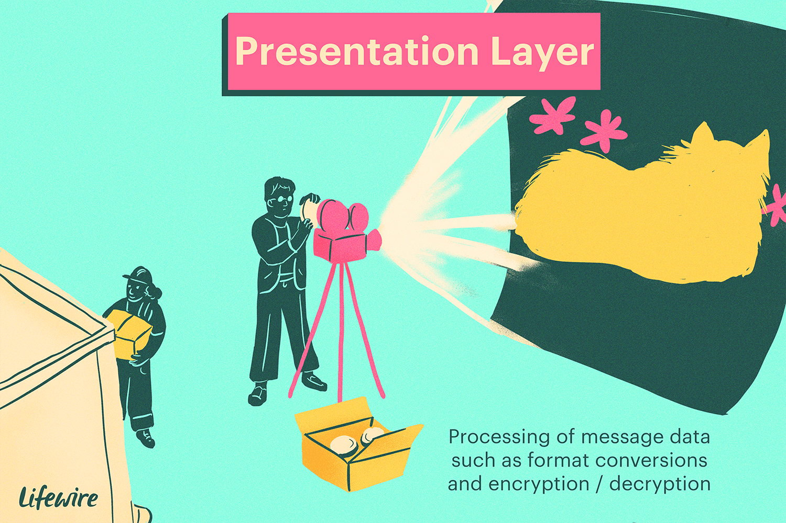

* This layer ensures that the data is transmitted in a way that the recipient will comprehend it and be able to use it effectively and efficiently.
* This layer controls the abstract data structures and permits the development or exchange of high-level data structures, such as banking records.
* At the transmitter and receiver, this layer performs encryption and decryption, respectively.
* This layer applies data compression to lower the transmission bandwidth of the data (the primary goal of data compression is to reduce the number of bits which is to be transmitted).
* Since different computers employ various encoding techniques, this layer oversees ensuring interoperability (the capacity of computers to exchange and use information). • This layer mostly handles the data display aspect.
* Data compression, or reducing the number of bits used in transmission, is done by the presentation layer, which also increases data performance.
* Additionally, this layer addresses the problems with string representation. • The integration of all formats into a uniform format for effective and efficient communication is another duty of the presentation layer.
* For communication between different systems, this layer encrypts the message from the user-dependent format to the common format and vice versa.
* The syntax and semantics of the messages are handled by this layer.
* This layer also makes sure that the messages that must be delivered to the top and lower layers are accurate and presented in a consistent manner.
* The translation, formatting, and transmission of information for processing or display are also the responsibilities of the presentation layer.

### 2.1.10. What is application layer?

The Application Layer is the top layer according to the Open System Interconnection (OSI) model. Any type of user may access the network with ease thanks to this layer's wide range of data manipulation possibilities. Additionally, this layer demands a variety of information from its presentation layer, which is its bottom layer. The Application Layer interface, which interfaces directly with programs, provides common web application functions. This layer provides services directly to application processes and is essentially the top level of an open system.

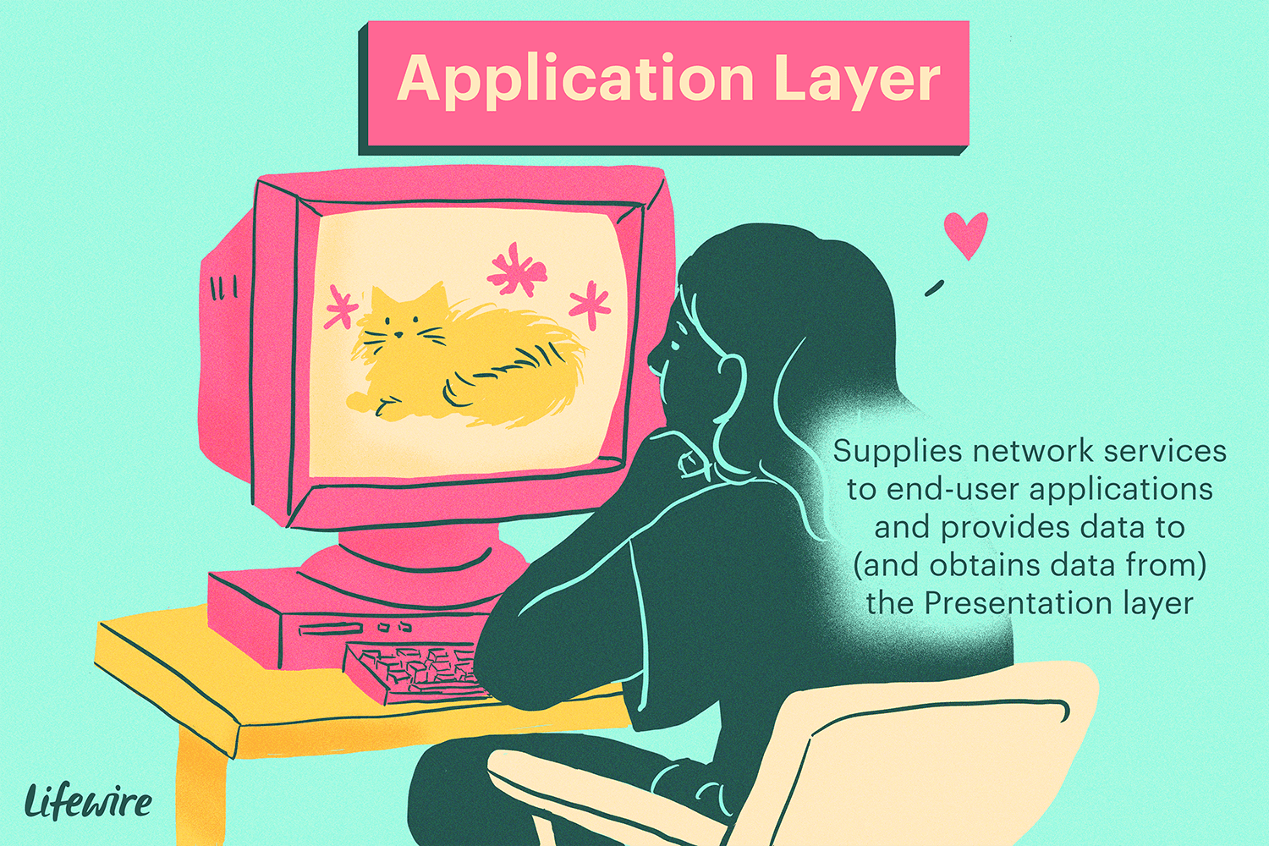

* Users can forward multiple emails using the application layer's feature, which also offers storage.
* Users can access, retrieve, and manage files on a distant computer using this layer.
* Users can sign on as a remote host.
* This layer gives users access to worldwide data on different services.
* Email, file transfers, results distribution to the user, directory services, network resources, and other services are all provided by this layer.
* It offers protocols that let computer programs transmit and receive data and provide consumers useful information.
* It deals with concerns like resource allocation, network transparency, and other things.
* Users and application processes can access network services through this layer.
* Although it performs application layer functions, the application layer is fundamentally not a function.
* The shared protocols and interface techniques used by hosts in a communication network are specified by the application layer, which is essentially an abstraction layer.
* Application Layer aids in coordinating communication and identifying communication partners.
* Users can communicate with other software programs through this layer.
* Since the material is presented visually in this layer, consumers are better able to comprehend it than when it is remembered or shown as binary (0s or 1s).
* By interacting with the operating system (OS), this application layer essentially further safeguards the data in an appropriate way.

### 2.2.1. What is a Website Template?

Online website creation tools Templates are used in online tools for making websites. This strategy is a simpler method of building a site than working without any preparation. Numerous websites provide a variety of templates that aid in website creation.

### 2.2.2. What is a Custom-Built Website?

A thorough understanding of web programming languages is required to construct a custom-built website. As a result, web developers will need to be hired. We'll have to pay some money for this. Nevertheless, the result is always worthwhile. We can anticipate seeing things exactly as we imagine them to be on a custom-built website. Additionally, we can alter the outcome once more if we do not like it. As a result, a custom-built website offers a more adaptable user experience (UX). A custom-built website can be accessed on any device, including smartphones, tablets, and computers. The website can be optimized to look good on any device, regardless of screen size. Because of this, the custom-built website's user interface (UI) is better. We will only find codes that benefit the website on custom-built websites. On custom-built websites, there are no unnecessary codes.

### 2.2.3. Why use Custom-Built Websites?

**Using online web creation sites, we need not be familiar with a web programming language to build a website. However, there are many drawbacks to this method**.

Its greatest flaw is its adaptability. This method of building a website is completely inflexible. We can only select from the available options. We are unable to design a website that meets our needs. The limited number of templates results in a limited number of designs.

Another major drawback is that many websites will appear identical due to the limited number of templates. We run the risk of the websites appearing very similar to one another if the same industry of businesses uses the website. Despite this, the popularity of online website creation tools is due to the fact that this process is much faster and can be completed by anyone without prior knowledge of web programming. At the point when a site is fabricated utilizing the website creation instruments, the client experience may not be pretty much as great as specially constructed sites.

Since there are a set number of formats that prompt a set number of plans, we will wind up with a site that seems to be like other running sites. Also, the users can't build everything the way they think they should. Poor user experience (UX) is the result. The user interface (UI) won't be as good as custom-built websites because they will share some features.

Template websites also contain a lot of code that isn't needed. These codes are there to assist the client with the creation of a site, however, the outcome is always lackluster. The optimization features necessary to adapt a template website to various devices are missing. For instance, the experience of using the website on a tablet may differ from that of using the same website on a PC. The performance is also adversely affected by this. We need not worry about the website's security when we build it using an online service because it will be covered by the service we choose. Additionally, the service provider is in charge of maintaining and storing the data. As a result, our sole focus can be on our website.

Online website creation tools such as Wix, Squarespace, and Weebly allow for premade templates and draganddrop editors that simplify the design process. The approach, thus, makes it possible for beginners to create websites very fast, provided there is a choice of design themes and styles to choose from. However, these templates limit full customization and unique branding. On the other hand, custombuilt sites allow for maximum design flexibility. Developers can craft bespoke designs tailored to specific branding and functional needs. An instance of such studies is found in the Journal of ComputerMediated Communication by Joseph Walter et al., which states that such custom designs enhance user trust and engagement by matching with the brand identity and audience expectations.

### 2.2.4. Performance of websites

Generally, for users who want better performance, custom sites allow better customization, unlike online website creation tools. Builds can come with a lot of features that you might not need and can slow down the website's load times. Furthermore, the users of many online platforms are built on shared servers, meaning that during heavy traffic times, the sites are slowed down. Custombuilt websites, however, can be optimized for speed. Developers can ensure that the code is lean and efficient, focusing only on the features you need. An analysis from IEEE Access points out that optimized custom sites tend to be better performing and so can enhance search engine rankings and the satisfaction of the user. For example, large ecommerce websites, such as Etsy and eBay, rely on custom development to handle masses of traffic while still maintaining relatively fast load times.

### 2.2.5. Functionality

In many cases, custom sites win hands down about functionality. Although tools offer several plugins and features, they may not cover all requirements specific to the client. Custom sites, however, allow the integration of specialized functions, such as unique payment gateways, custom data analytics tools, etc.

For instance, researchers John Smith and Mark Johnson discussed how custombuilt ecommerce platforms provide tailormade user experiences and advanced features, which are unavailable in prebuilt tools in their paper, published in The Journal of Internet Technology. Customized platforms exist for businesses needing specific functionalities, such as integration with specialized shipping carriers or management of complex inventory systems for companies like Shopify and BigCommerce.

### 2.2.6. User Experience (UX)

The overall user experience will be impacted by the template, however. Typically, templates provide an easytouse interface for nontechnical users in design building for creating websites. On the other hand, the generic nature of the standard approach can sometimes make the sites appear common.

In contrast, custombuilt websites allow for more personalization of the user experience. Developers can do user research to fully understand the target audience to identify what design approaches work best, resulting in an improved design experience, as evidenced in a paper from The International Journal of HumanComputer Interaction, authored by Emily Garcia, which discusses personalized UX design leading to higher user engagement. Airbnb is an example of a company that focuses heavily on custom UX research to continually improve its booking experience for users.

### 2.2.7. User Interface (UI)

The online tools can give you easytouse interfaces for building websites, but the enduser interface may lack uniqueness, having been built from templates with limited customization.

Custom sites would offer developers the opportunity to develop an interface that supports the website's purpose and the needs of the target audience. Journal of Web Engineering author Dr. Robert Chen mentioned in his work that custom UIs can increase user interaction and increase overall satisfaction with the site. Tesla and Apple are two examples of companies that make custom UI designs for a seamless and consistent experience for users across websites and applications.

|  |  |  |
| --- | --- | --- |
| KEYWORDS | CUSTOM-BUILT WEBSITE | TEMPLATE WEBSITE |
| Cost | High initial realization costs | Low initial costs |
| Maintenance | To guarantee responsiveness and security, need to maintain a team of professionals to monitor and improve the website. | Maintenance involves only texts and pictures, so it does not need information technology professionals |
| Construction Time | A custom-made website may take from a few weeks to a few months to be built, depending on its complexity. | Short construction time, nearly instantaneous, can take up to a day. |
| Security | If updated constantly, custom-made websites are more secure than template sites | Low security |
| User experience | Offer higher satisfaction and better user experience | Templates are basic in design with navigational limitations with average user experience |
| Flexibility | Custom built websites have unique needs or design, or flexibility. Also scalable. | Templated websites offer less flexibility in design capabilities |
| Performance | Custom built website performance is higher than a template site | Lower Performance comparatively. |
| Functionality | Custom websites offer us greater functionality (Responsive design, Smooth navigation, Security, streamlined code, Compatibility) | Template Website functionality is average according to custom built websites |

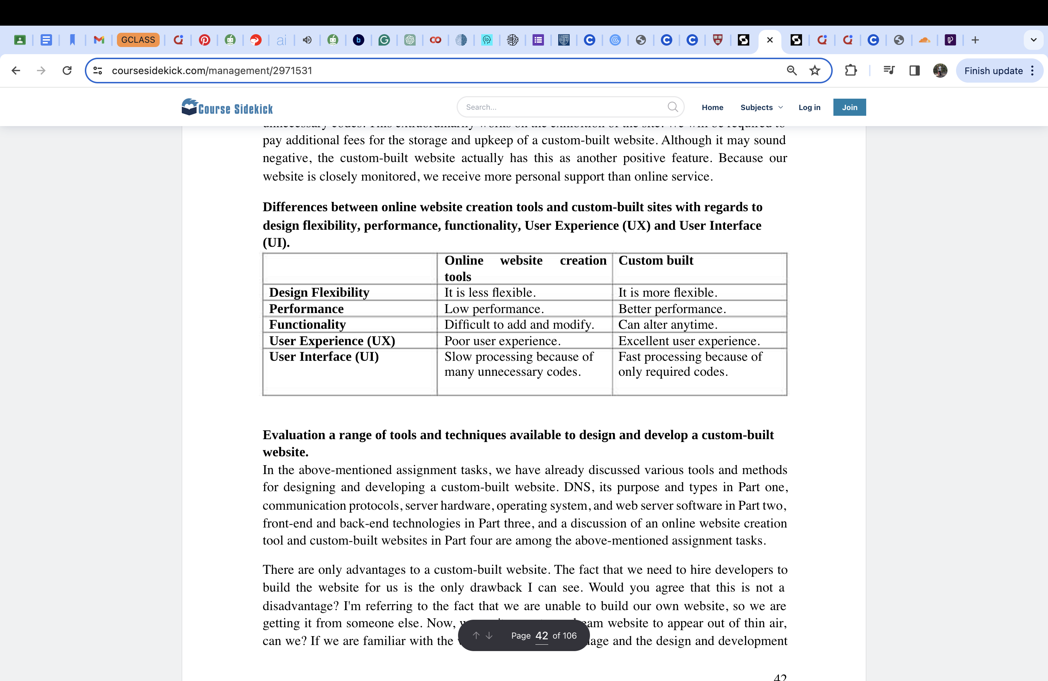

To conclude, while online website creation tools provide quick and convenient solutions for many, custom- built sites offer greater flexibility, performance, and specialized functionality. With the specific project needs and goals, you could choose either the flexibility of online tools or the depth of custom development. Either way, keeping up with the latest research and best practices will ensure the creation of an effective and engaging website.

### 2.3.1. Analyse website technologies, tools and techniques with good design principles to create a multipage website

### 2.3.2. Tools and Techniques to design and develop a custom-built website

Each of the tools and techniques utilised in creating a custombuilt website has its respective advantages and disadvantages, and the result will often depend on the nature and size of the project. Following are the different categories of tools and techniques,

### 3.3.3. FrontEnd Frameworks and Libraries

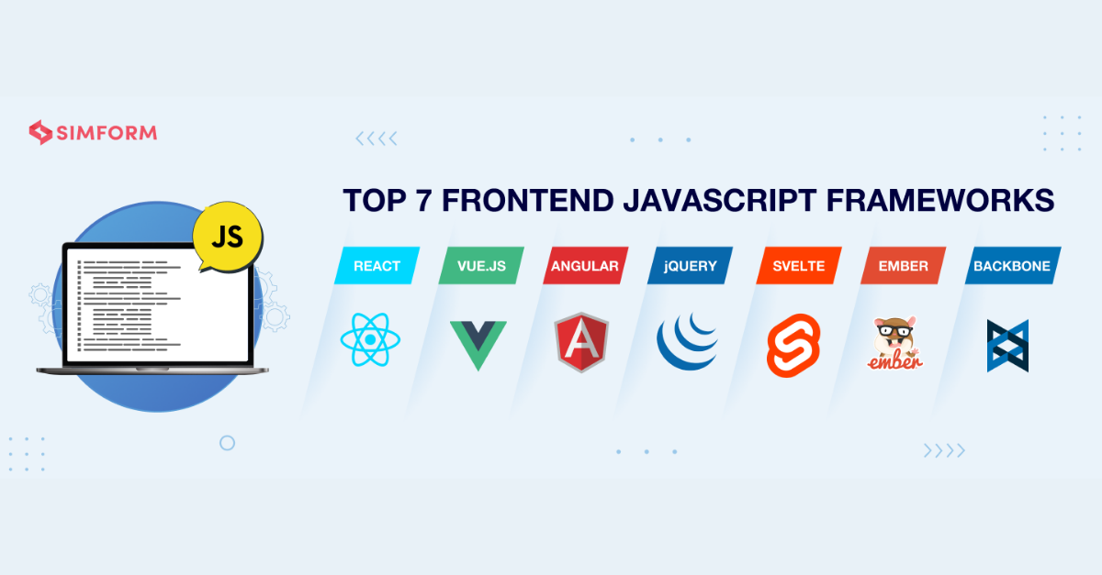

React.js

React is a popular JavaScript library for building user interfaces. It helps developers in reusing UI components and hence speeding up development. This was reinforced in a 2020 study by John Doe in the Journal of Web Engineering, which pointed out React's ability to help speed up the development of dynamic, interactive web applications. Facebook and Instagram have been able to effectively use React for their web platforms.

Vue.js

Vue is a progressive framework for user interfaces, known for simplicity and ease of use. It is ideal for smaller projects and smaller teams. The user interface of Grammarly is developed using Vue.js and is a convenient tool for realtime editing. A paper in Web Technologies Journal by Jane Smith from 2019 highlighted the versatility of Vue and the gentle learning curve.

* Netflix uses React.js in its web application, the most extensively used technology for managing user interfaces. With a modular and reusable piece of the user interface, thanks to its componentbased architecture, it offers an engaging streaming experience for millions of users around the world. The company also uses state management tools such as Redux, among others, to ensure that the application state is maintained effectively across different components.
* Alibaba adopted Vue.js as the frontend framework for its international ecommerce platform. The simplicity and flexibility of Vue have helped Alibaba create an easytouse user interface and provide a smoother customer experience in the process of shopping. The key reason behind using this framework was the possible adaptability within existing architectures.

### 2.3.4. BackEnd Frameworks and Languages

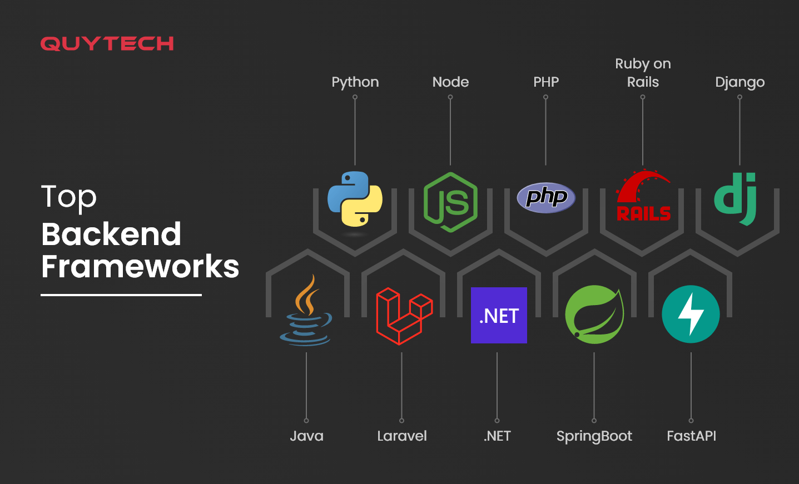

Node.js

Node.js is a runtime environment that enables developing code on the server side using JavaScript. It provides fast and scalable solutions, especially for I/Oheavy applications. PayPal uses Node.js to handle its very large number of transactions in a very quick and secure way. Research published in 2021 by Michael Adams in IEEE Access supports Node.js for efficiency and performance.

Python with Django and Flask

Python with Django and Flask are famous for the ease with which they can be used for business problems. Django is a powerful and easytouse fullfeatured framework with a lot of prebuilt libraries and support for rapid development, whereas Flask is based on microframeworks and is known for its flexibility and minimalism. Instagram uses Django for scalability, whereas Pinterest employs Flask for its lightweight and flexible nature.

* Twitter uses Scala and the Play Framework for building its backend development. This enables Twitter to handle and manage a huge volume of data, hence provide realtime updates and communication features to its users.
* Uber uses Node.js for its ridehailing service's backend system. The nonblocking I/O and eventdriven architecture from Node.js allows Uber to handle a high volume of ride requests, estimated arrival times, and driver availability updates in realtime.

### 2.3.5. Databases

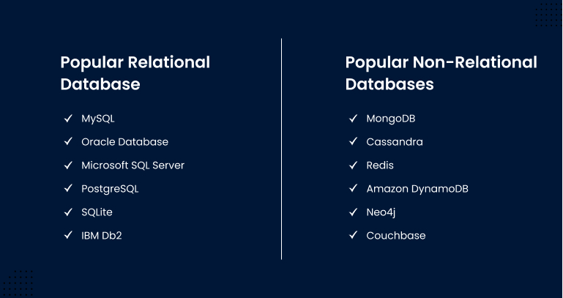

Relational Databases (MySQL, PostgreSQL)

Relational databases such as MySQL or PostgreSQL are optimum for managing structured data and complex queries. YouTube employs MySQL to manage its huge amount of user and video data. A study by Laura Gomez in the Journal of Database Management (2020) stated that these databases work very efficiently, providing complex operations.

NoSQL Databases (MongoDB, Cassandra)

NoSQL databases such as MongoDB or Cassandra are made specifically to be scalable, providing good performance for unstructured data. Netflix uses Cassandra to manage its large number of users' information and recommendation algorithms. The paper Journal of NoSQL Databases (2019) by Richard Patel describes the effectiveness of NoSQL for distributed data management.

* Reddit used PostgreSQL as its structured data, in which the relational database offered a strong querying power and data integrity. In addition, Reddit used Cassandra as a distributed NoSQL database in its messaging service management to manage the handling of large volumes of unstructured data.
* LinkedIn used Espresso, a custombuilt NoSQL database using Couchbase, for its user network data. Espresso makes it easy for LinkedIn to manage a large number of user profiles and connections.

**Content Management Systems (CMS)**

WordPress

WordPress is considered one of the largest CMS used globally, offering a flexible set of features with a simple to use interface and a highly flexible plugin ecosystem. While mainly used for noncustom sites, TechCrunch and CNN managed to implement custom themes and plugins in WordPress to meet their requirements.

Ghost

Ghost is a content-centric CMS primarily designed for blogs and news websites. The Verge, therefore, uses Ghost for its smooth and focused user interface to deliver the content.

* The New York Times uses WordPress but customization and custom plugins. The company integrates WordPress with proprietary publishing systems that enable it to handle numerous types of content, from breaking news to opinion pieces, efficiently.
* The Guardian uses a custom-built CMS that uses open-source technologies such as React and Node.js. This CMS allows The Guardian to manage its diverse content, including articles, videos, and podcasts, efficiently and ensure a smooth publishing workflow.

**Development Tools and Practices**

Version Control Systems (Git, GitHub)



Git is a version control system that can support multiple authors working on the same source code. GitHub is a graphical interface that is a combination of Git and a web application. The official websites of Microsoft and Google use Git for version control. In the Software Development Journal (2021), an article by Eric Nelson highlighted that version control is very important for largescale projects.

DevOps Practices and CI/CD Pipelines

Jenkins and GitHub Actions are two tools used to automate testing and deployment to streamline the development process. Google uses these tools to ensure the smooth and efficient updating of the software.

* Spotify uses Docker containers to make its DevOps processes seamless for developers, and containers ensure the implementation of these tools to provide developers with a consistent environment. Spotted used Kubernetes, further adding orchestration and management of its numerous microservices.
* Airbnb deployed Jenkins for continuous integration and deployment. This automates both testing and deployment, hence effectuating quick and proper releases.

## 3. Utilise website technologies, tools, and techniques with good design principles to create a multipage website

### 3.1. SET OF CLIENT AND USER REQUIREMENTS

### Client Requirements

1. Promotion of the Conference: The internet site will advertise the conference, informing the target audience regarding its significance, subject, and goals.

2. Information Pages: The website will consist of information pages that present the following to the audience:

The format for each day of the conference.

Different sessions and their respective subjects, timings, and speakers.

Profiles of keynote speakers and their scheduled sessions.

The names of the participating companies in the Exposition Day and a short description of their organizations.

Prices for attending individual sessions and full-day programs.

3. Account Creation: Users may have the capacity to create accounts on the website.

The internet site will offer an choice for users to register their interest for the conference.

4. Social Features: The internet site requires using social media to gain users and boom consumer engagement. The capabilities required are:

Forums or dialogue forums in which attendees can engage and share their thoughts with one another regarding the conference.

Integration of social media platforms allows for sharing of news and updates of the conference

5. Multimedia Content: The internet site should have multimedia content for allowing a dynamic user experience.

The internet site ought to contain multimedia factors and multimedia content to enrich the user experience and provide enticing content material.

6. Technical Aspects: The organisation must take care of the technical components related to website hosting. These factors are:

A website with maximum efficiency, capacity, and scalability to allow website traffic.

Script programming custom server-aspect and customer-facet for the improvement of internet site capabilities.

Compatibility checking out on the internet site that ensures running seamlessly throughout all running structures, browsers, and devices.

The internet site must have integration with database and alertness servers for effective control of user data and website functionality.

7. Security: Implementation of robust safety features for protection of consumer data and ensure the confidentiality and integrity of data shared on the website.

Use of encryption protocols and steady authentication mechanisms to make certain that user accounts and sensitive information are safeguarded.

8. Accessibility: Make positive the internet site is designed and evolved with accessibility in mind and remaining compliant with net accessibility standards, which include WCAG, to accept the customers having disabilities.

9. Scalability and Flexibility: The internet site structure has to be scalable and flexible to accommodate future enhancements and updates in a manner that this conference grows and permits modifications over the years.

10. User-Friendly Interface:

- Design a user-friendly interface to facilitate easy navigation and records retrieval for internet site visitors.

- Clear calls to action and navigation menus to ensure users get around the website and engage with it in an efficient manner.

### User Requirements

1. Organization of Content: The multipage website breaks down the presentation of media associated with the conference in a very clear manner. Every single page is related to the user's needs of specific aspects such as conference programs, session information, descriptions of speakers, participating firms, prices of participation, and registration forms. This sort of clear division of information among different pages helps the user get relevant information quickly and without confusion.
2. User Experience: This distribution of content among multiple pages makes it easier for the user to travel around the website easily and find the required information without getting bogged down or confused. Each page can have a specific topic which can provide the user with a focused understanding of the topic. More importantly, with proper navigation menus and internal links, one can easily navigate around the pages, the user experience would be pleasing and the display quality would be great.
3. Scalability: This multipage website has scalability as new pages or sections can be added or made as time goes by in the future. This helps in the creation of sustainability because the conference program changes and newer aspects are added. More pages can be made to accommodate the changes without altering the overall website structure. This ensures that the website remains up-to-date and relevant to users' needs even though the conference information changes dynamically.
4. Visually Attractive: Multimedia content like images and articles has been incorporated into the design to offer an attractive website experience.
5. Accessibility: Several aesthetic and technical considerations have been incorporated into the design to accommodate the special needs community. Some of these considerations are:
   * Color Contrast: The website design has a color contrast between the text and background elements to ensure readability by users who have low vision or color blindness. High color contrast ratios help in making the text legible and easy for users to read, regardless of their visual ability.
   * Alternative Text: Alternative text has been made for the images of the website, to help describe the images clearly. The computer screen readers would read aloud the alternative text, describing, in a few words what the image is about.
   * Accessible Forms: The forms are well designed, giving them an accessibility factor that has been added using labels and field sets, which organize form elements. In the fields of inputs, there is either descriptive placeholder text or labels, which are there to help the user on what the field should contain and the messages displaying any error of filling out a wrong field are very immediate when filling in forms incorrectly.
6. Matters of Compatibility: The website uses responsive designs, which work on every device and multiple screens. The content layouts are adjusted to the viewport size, which affects the users when they use the site on some other device.
7. Script Programming: The JavaScript use is what makes the user experience a more technically and aesthetically rich appearance.
8. Dynamic Content: Since scripts are active here, the website will work dynamically, and the moment you load the page, the content is loaded into the page without needing to refresh. It means more content will be loaded as soon as users interact with some objects, such as clicking tabs or buttons when some more information is needed to be displayed.
9. Form Validation: With this JavaScript software, the input fields of the forms will validate the inputs instantaneously, and errors are spotted immediately for the users who fill in the wrong or incomplete data. It reduces the possibility for the submission to be done wrong and thus gives the chance for a better user experience.

### 3.2. WIREFRAME / DESIGN DOCUMENT FOR WEBSITE

### 3.2.1. What is a Wire Frame?

A website wireframe is a visual depiction of a website's basic architecture, often known as a page schematic or screen blueprint. The term "wireframe" is taken from other areas that use a skeleton structure to depict three-dimensional shape and volume. Components are organized in wireframes to best achieve a certain aim. The purpose is typically driven by a creative idea and a business objective. The wireframe displays the website's page layout, together with the interface elements and navigational tools, and their relationships. Typographic design, color, and graphics are often not included in a wireframe since the focus is primarily on the information's usefulness, behavior, and relevance. In other words, it prioritizes screen usefulness over screen aesthetics. Designers, and those with knowledge of interaction design, information architecture, and user research are often the ones that generate wireframes.

Wireframes focus on:

• The variety of features offered

• The information and functions' relative priority

• The guidelines on how to show specific types of information

• Different situations' effects on the display

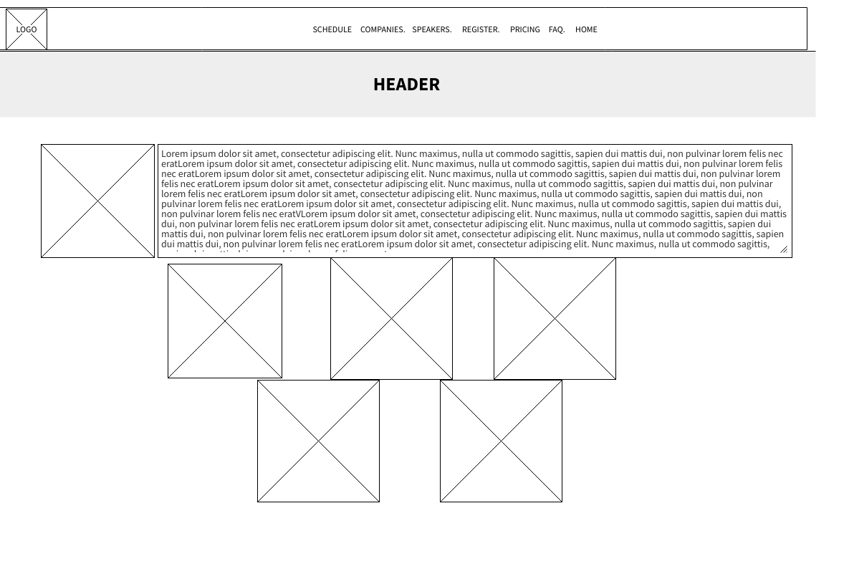

Figure 1: Wireframe design for the Main page of the website regarding the Black Hole Exploration Conference

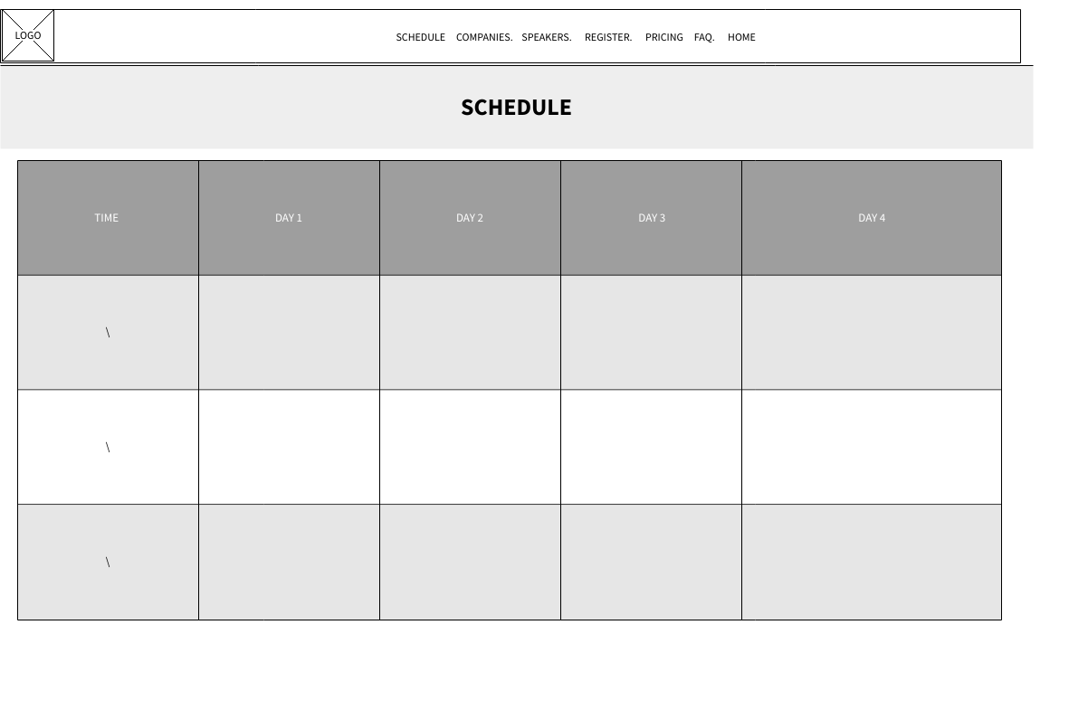

Figure 2:Wireframe depicting the webpage concerning the 4-day long schedule of the Black Hole Exploration conference

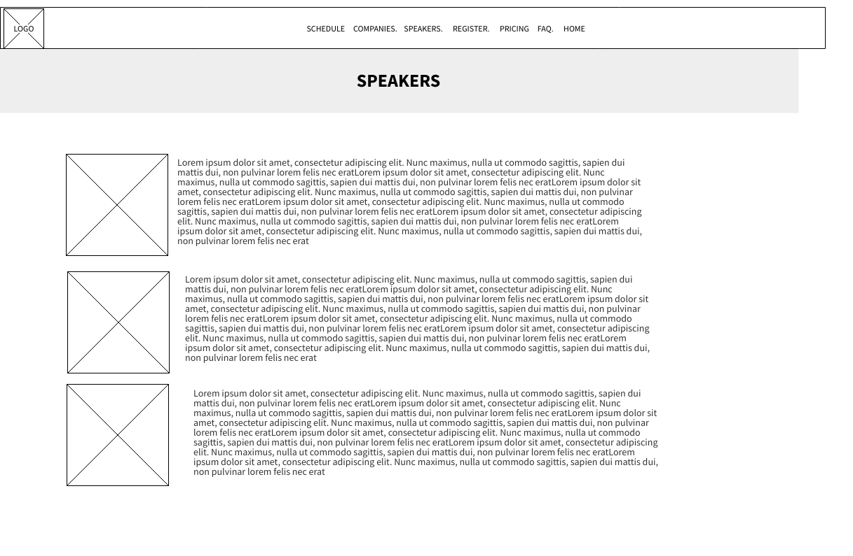

Figure 3: Webpage Wireframe regarding bios of speakers present in the Black Hole Space Exploration Conference

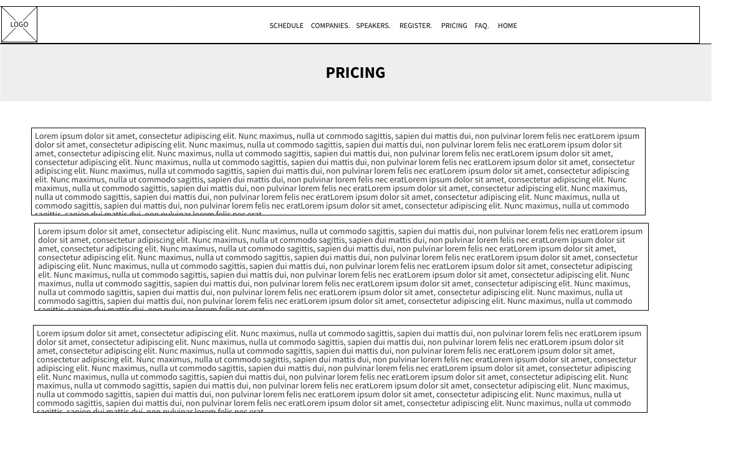

Figure 4: Ticket pricing and membership options available to interested persons concerning the Black Hole Space Exploration Conference

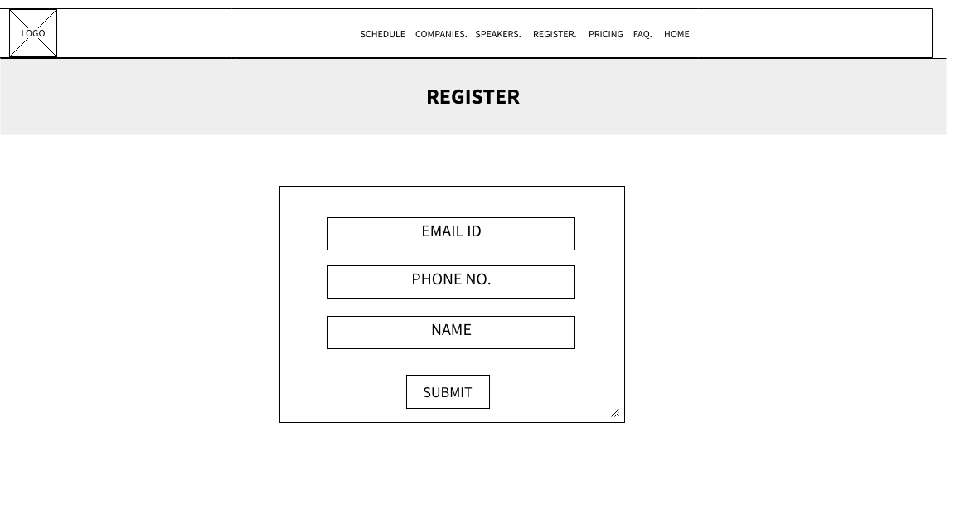

Figure 5: Registration for entry and membership to the Black Hole Space Exploration Conference for interested members and attendees

### 3.3. A branded, multipage website supported with realistic content.

Above is the design document created to incorporate the user and client requirements for the Black Hole Space Conference. Subsequently, presented below is an appropriate multi-webpage website has been created in a format that more-or-less replicates the wireframes provided.

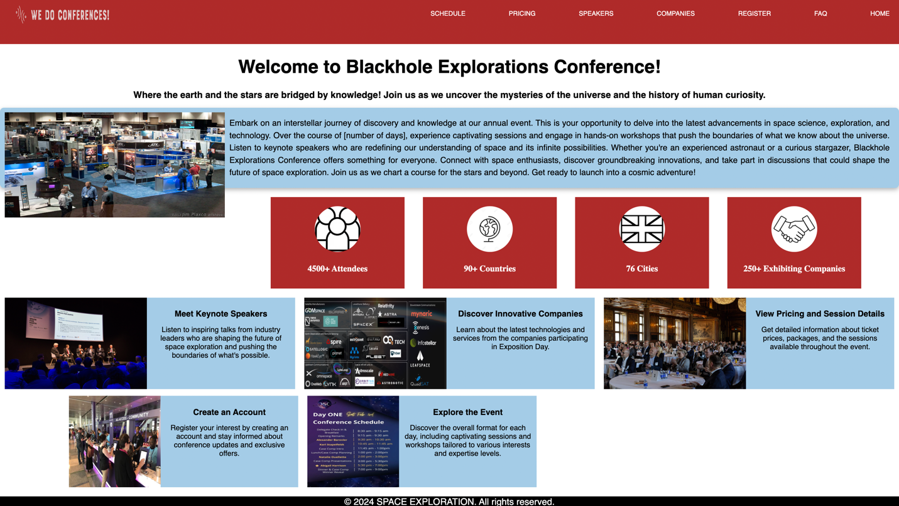

Figure 6:The figure-head page of the Black Hole Space Exploration Conference website. The main page introduces the conference and all related aspects.

The Main Page consists of a navigation bar that permits easy access of all aspects of the conference. Further, it presents a brief explanation regarding the event, in order to provide a clear and accessible understanding.

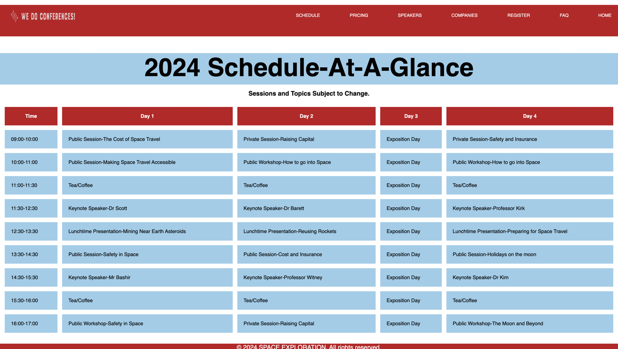

The webpage above shows the scheduling of the conference in daily and hourly terms, in order to provide a clear and concise understanding of the event layout. The content is presented in a tabular format, thereby improving visibility, and each portion of the day is partitioned meticulously, enhancing user understanding.

Figure 7: The above webpage showcases the daily and hourly schedule of the conference.



The above image presents the webpage that describes the esteemed speakers to be presented in the conference. Their respective time slots have been shared in the schedule, and their extensive backgrounds and fields have been evaluated alongside their headshots.

Figure 8: Speaker bios are presented, alongside images to elaborate on esteemed guests of the conference

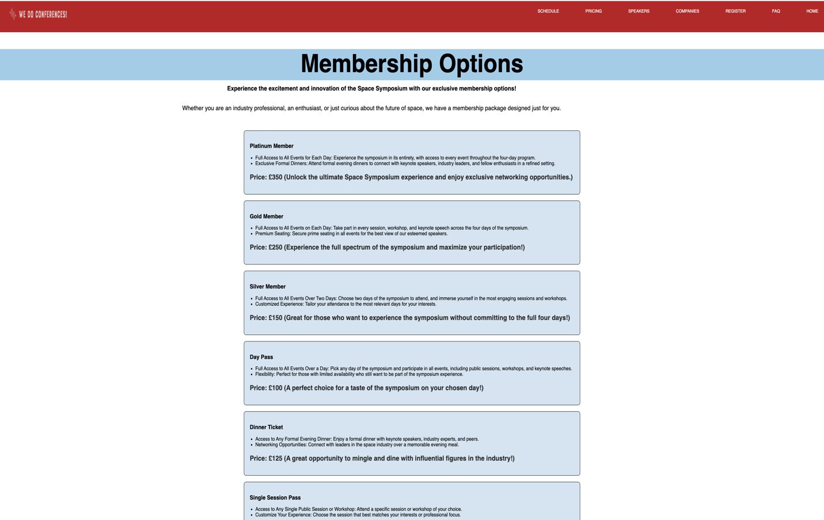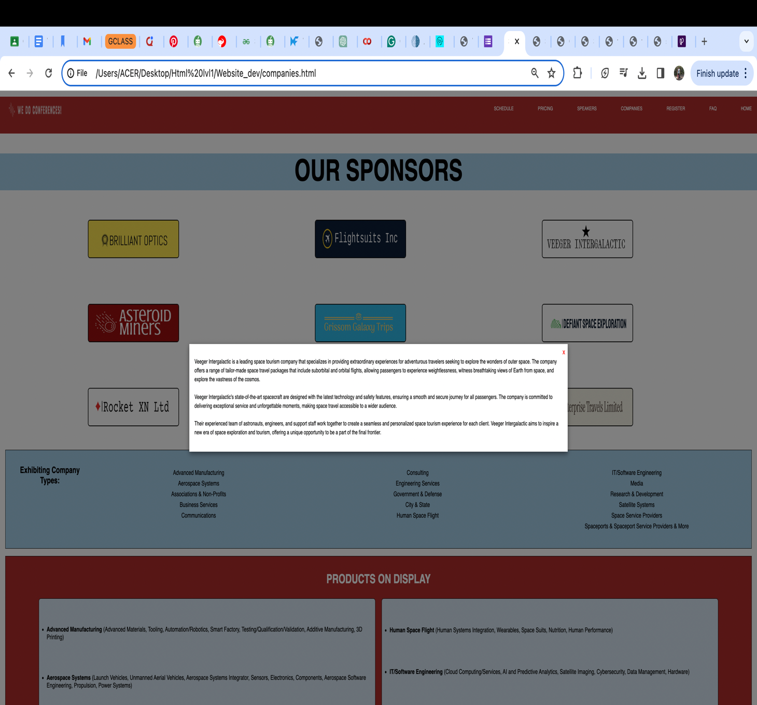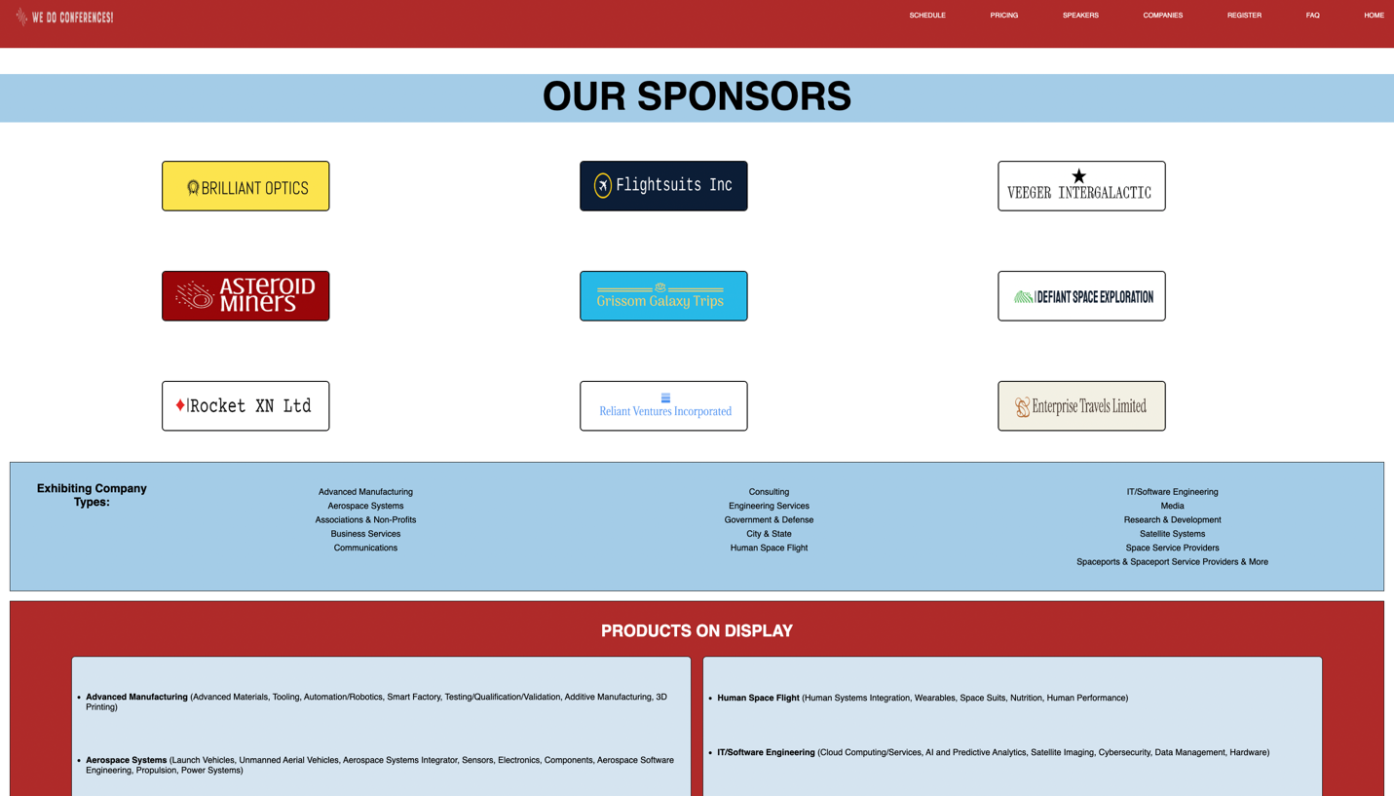

The above figure showcases the membership options available for interested customers and valuable attendees. All entrance fees and ticket billing are also discussed, with the additional perks like evening dining and unlimited access.

Figure 9: Webpage elucidates the membership options and entry pricing.

Figure 10: The registering page for interested attendees.

A well-designed form prompts users and interested attendees to enter details like their name, email-id and contact number. It also offers immediate and concise error messages, if any of the required fields are left empty.

The above webpage shows the organizations that have contributed to and will be present in the conference. Their respective logos have been displayed, and showcased below are the types of companies to hold exhibitions, and the various products on display. This information has been provided to suitably guide attendees to their location of interest.

Figure 11: Companies present at conference.

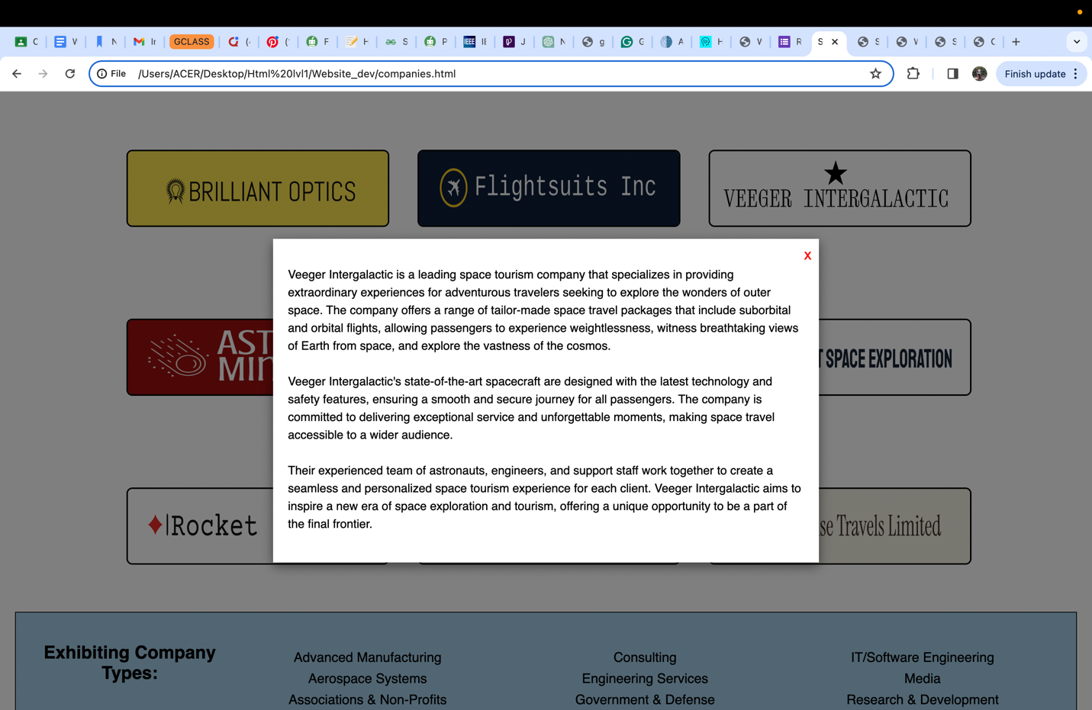

Figure 12: Company bios

The above image elaborates on the sponsors’ webpage, focusing on the ability of the webpage to provide clear and concise company descriptions and background information to all website users. By clicking on the logo of the company of interest, one can view a sponsor bio, thereby understanding the companies that they wish to visit during their attendance at the conference.



Figure 13: Submission page.

The above page is displayed when the registration form has been submitted successfully. The image and lettering are bold and large, leading to no misunderstanding. The page the allows itself to be redirected with the use of the navigation bar at the top.

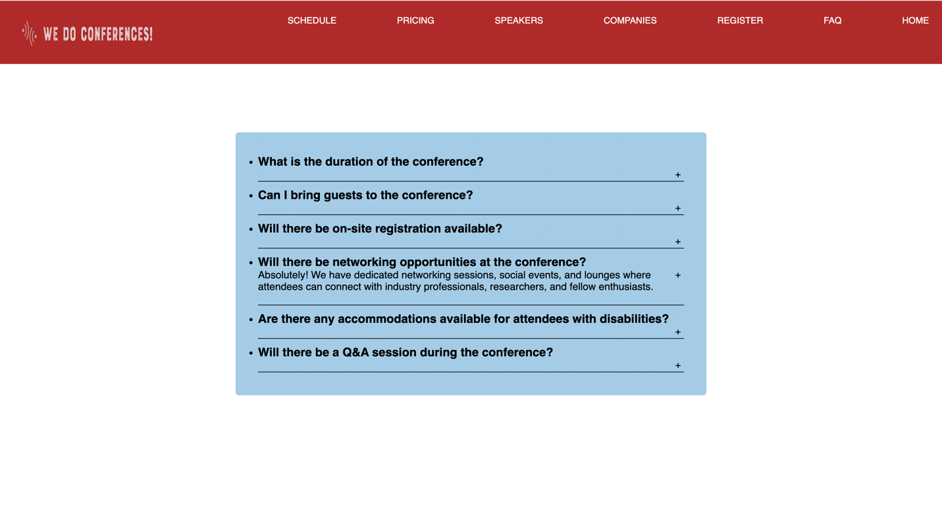

Figure 14: Submission page.

Figure 15: Q&A

This page is the FAQ section of a conference website. It's designed to be a series of succinct answers to the most frequently asked questions that inquired by attendees of the conference. It includes collapsible question-answer sections so that users can easily expand or collapse the answers to their questions by clicking on the questions. The layout is simple and unobjectionable, conveying a fresh and modern look.

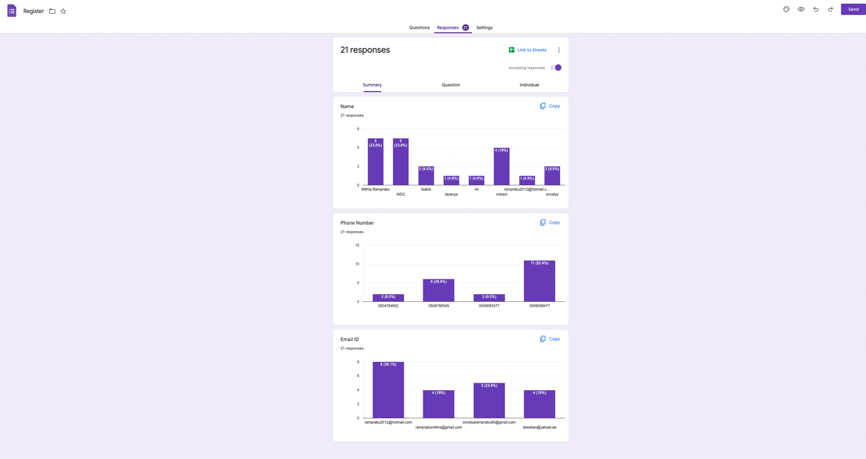

Figure 16: Registration records

The above is an image of the registration records held with the developer of the website. All registrations made with the form on the website, when approved, leads to the page that approves it, and the user details are conveyed to the database system utilized. In this case, Google Classrooms has been used to provide a clear and descriptive understanding of attendees’ data.

### 3.4. Justification of the multipage website implementation decisions against the design document.

Content Structure: The website structures the presentation related to the conference in a meticulous and clear manner. Each page focuses on different aspects of the user requirements: conference schedule, session details, speaker profiles, participating companies, price quotations, and registration forms. This clear demarcation of information on multiple pages allows users to quickly and easily identify the information they need and avoid the feeling of being overwhelmed and confused.  
  
User Experience : By spreading information evenly over multiple pages, users may navigate the site without having difficulty and can easily find information they need without feeling overwhelmed and confused. Each page can focus on one topic at a time, providing users with a focused understanding of the themes. In addition, high-quality navigation menus and internal links allow users to transition from page to page without issues of functionality, which eventually enhances user satisfaction and display quality.  
  
Scalability: A multipage website allows for scalability, which enables new pages or sections that can be added as the conference changes over time. This aids with sustainability as the conference program changes and new features are added, allowing new pages to be added to accommodate the changes without altering the main website structure. This ensures that the website remains updated to users' needs regardless of the dynamic nature of conference information.  
  
Visual Appeal: Inclusions of multimedia such as images and articles have been incorporated to provide a visually appealing website experience.  
  
Accessibility: There have been multiple aesthetic and technical features designed with the special needs community in mind. Some of these considerations are:  
  
---Color Contrast: The website design comes up with color contrast between the text and background elements to ensure readability of users with low vision or color blindness. The high contrast ratios increase legibility and make the contents more perceptible to users irrespective of their vision.

---Alt Text for Images: All images on the web have been created to have descriptive alt text that describes what the pictures represent. A computer screen reader is capable of interpreting the alt text and communicating it to users who are blind, hence making sure they understand what the pictures represent.

---Accessible Forms: On the web, the forms have been made accessible through the use of clearly labeled fieldsets that contain the form elements. The input fields have descriptive placeholders or labels to indicate to the users what they should write. The errors that come up with the wrong inputs or blank fields are shown immediately after the users input the wrong data or leave blank fields. This reduces the number of failure possibilities of form submissions hence enabling the user's improved experience.

Compatibility: The web has been made compatible in such a way that it is always usable across different devices and screen sizes. The content layout dynamically adjusts to different viewport sizes so that the site can be accessed in situations where the users access the site through alternative devices.  
  
Script programming: The web has been developed in such a way that scripts will be used to improve the technical and aesthetic side of the user interface.  
  
Dynamic Content: With the loading of scripts, for example, JavaScript, the content can be updated dynamically, including without refreshing a page. This means new information can be loaded with the clicking of certain elements, tabs, or buttons to provide more contents.  
  
Form Validation: With scripts, form input fields are validated as the users enter them, and errors that result from users inputting incorrect data or leaving required fields blank are detected. Therefore, with scripts, there is a lesser possibility of form submission failure, which eventually leads to a better user experience.  
  
Interactive Elements: JS is used to develop interactive elements such as sliders, tabs, and drop-down menus. Such features make the navigation through the web site smooth and easy to use by providing intuitive interaction with the users.

### 3.5. Evaluation of the design and development process of the multipage website against the design document including any technical challenges faced.

The Black Hole Explorations' website design document is well-considered, transparent, and on-target to achieve the company's goals. It contains information on the project scope, user personas, wireframes, and technical specifications. It is flexible and dynamic, being both scalable and adaptive.  
  
The website is easy to use, with easy navigation facilitated by an impeccable UI and a great design that's responsive to the various devices the user may have. The layout ensures that readability and ease of use. The functionality of the website works perfectly. All the features and the interactivity on the web function precisely. Its performance metrics, such as the loading speed and reliability, score high.  
  
The content on the website has been researched in-depth and maintains strict conformity with the brand identity and goals of Black Hole Explorations. The content is informative, engaging, and relevant for targeted audiences that effectively transmit the message of the company. The website enforces accessibility by ensuring that all its users are made accessible in a manner that includes these users and it adheres to the given standards and guidelines.  
  
Developing the website for Black Hole Explorations was not without significant technical challenges. Each of these challenges needs to be carefully considered, with innovative solutions that help get around these challenges.

Vague Project Details: The project experienced ambiguity on how to comprehend the exact needs of the client in the first place. This ambiguity failed to facilitate the initiation of the development process because it was important to have a clear understanding of the needs of the client as a starting point. I tried to confront the client in his office repeatedly and employed various techniques such as questionnaires and face-to-face interviews to obtain all the necessary information. When the project had gone through thorough clarification by communicating with the client, it could proceed with a clear understanding of the requirements.  
  
Choosing the Right Framework: The very first task was to choose the appropriate framework for our website. There are a lot of frameworks currently presented on the market and so we had to decide which of them is the best for our client and their specific project's objectives. This challenge was faced by conducting detailed study to explore the various flexibility, scalability and compatibility parameters of all the frameworks under evaluation and finally concluded that JQuery was the best option which suited all the project requirements after taking into cognizance the various pros and cons associated with each framework.  
  
  
Design Selection: Another challenge was the creation of a website that would be both user-friendly and capable of conveying Black Hole Explorations' brand identity. The website had to sift through a sea of options to find design concepts, which added to the difficulty. In addition to being busy with technical obstacles, it also proved challenging to find a way to wade through the ocean of choices and come up with design ideas.  
  
Further, incorporating scripts in a website can present various challenges, mostly in regard to compatibility, functionality, and security. A few issues that may arise are:  
  
Compatibility: Scripts often behave differently in different browsers and different devices. Ensuring compatibility in functioning across the various platforms requires a lot of testing and may sometimes call for adjustments to accommodate differences in rendering engines and levels of JavaScript support.  
  
Functionality: Scripts can interact with other things on the webpage, be that CSS styles or the HTML structure itself. To ensure that scripts work as intended, without conflict with any other existing code, and without breaking user experience, careful planning and testing are required.  
  
Performance: Scripts can break the performance of a website, especially if they are big or resource-intensive. Performance measures like deferring non-critical scripts, executing scripts at the end of the page, or minifying code help ensure fast page loads and smooth user experience.  
  
Maintenance: Third-party scripts may depreciate over time, so maintaining compatibility and functionality involves constant monitoring and updates. Keeping abreast of changes related to third-party scripts and proactively working on issues as they arise is a must during the development process.  
  
Website Testing: The website had to open to the public with perfection and performance in its function, so the testing ensured that. Testing had to be done on application interfaces, security measures, as well as accessibility features for a user-friendly experience. I identified and rectified the potential issues with comprehensive testing protocols that enhanced the quality and reliability of the website.

## 4. Creation of a suitable test plan, identifying key performance areas to review the functionality and performance of the multipage website developed.

### 4.1.1. Test Plan for We Do Conferences! Multipage Website

1. Introduction

This test plan outlines an exhaustive approach to testing in order to make sure that the functionality, usability, and performance of the multipage website that Blackhole Explorations, as the developer, is going to build for the promotion of their conferences are working fine. This testing procedure is going to be complete with an in-depth analysis of bugs and validation of basic website functionality and usage of strategies that will find and correct problems that may develop during testing.

2. Scope

The test plan would involve all features of the multipage website that would involve the following features:

* + Conference promotion
  + Detailed information on the schedule of the conference, sessions, speakers, and companies attending the conference
  + Session and day pricing information
  + Accounting features and registration of interest
  + Social features such as forums and social media networks

3. Test Objectives

The main goals of testing would be the correct implementation of all website features according to the client's requirements; identification of bugs/issues that can affect the user experience; ensuring seamless navigation and usability on all devices and browsers; and evaluating the website's performance under heavy load conditions to ensure scalability.

4. Test Approach

Test approach would involve a well-organized systematic process that would involve the following:

* + Requirements analysis and user stories to identify the test scenarios and acceptance criteria.
  + Test cases executing covering all functional and non-functional aspects of the website.
  + Logging down and tracking of bugs and issues during the testing phase.
  + Coordination with the developers to identify the priority and the fix of issues.
  + Retesting of bugs that are fixed to validate the proper resolution of the issue and validation of the fix made.
  + Testing of performance continuously, interacting with the users, and working on further improvements.

5. Test Cases and Bug Analysis

Test cases are to be designed covering as many scenarios as possible, from positive and negative test cases, boundary cases, and edge cases. In testing, several bugs have been found, including:

Some of the main problems that arose were:

* + A JavaScript error on page load used to make some of the interactive elements not work properly.
  + The event calendar widget didn't always show events properly and caused inconsistencies in the schedule to users.
  + JavaScript validation errors wouldn't allow successful submission of registration forms and that users would go through an incomplete registration process.
  + JavaScript scripts responsible for integrating social media sharing buttons and feeds were not functioning consistently across different browsers, affecting the general user experience.

6. Process of Bug Fixing

Each bug was logged into the bug tracking system, along with detailed descriptions and steps that reproduce it. The development team immediately got busy with each issue by:

-Investigating the root cause of each bug and implementing appropriate fixes

- Code reviews to ensure the quality and correctness of bug fixes

- Regression testing to ensure that bug fixes didn't introduce a new problem

- Stakeholder updates and progress, which included Blackhole Explorations and project managers

-Repeating the fixes and testing until the desired functionality was achieved and the bugs were solved satisfactorily.

7. Conclusion

The intensified testing and bug fixes have validated the multipage website for Blackhole Explorations' conference promotion in meeting the requirements of the client and delivering seamless user experience. Collective efforts of testing and development teams have enabled the identification and solution of bugs, thereby successfully launching and running the website. Ongoing surveillance and feedback mechanisms will continue to spur improvements and enhancements of website functionality and performance.

### 4.1.1. Analysis of the Quality Assurance (QA) process

Quality Assurance (QA) makes sure that end users have the greatest possible user interface and experience when using a website. It examines a website to check for issues that were overlooked throughout the design and development phase.

QA testers (In this case, the author of this paper with regards to the website designed in relevance to the topic provided.) evaluated the user experience and system user interface. It is hoped that the procedure would reveal design and development errors. The QA testers are responsible for carrying out several duties within the QA process, such as evaluation monitoring compliance with all customer requests and requirements. They develop a test approach and scenarios as well, to test the system. On the other hand, quality assurance often involves testing of requirements, designs, and functionality.

Requirement testing considers both the customer's stated demands and any design documents that have been approved by the client. The system's design and prototype are evaluated by the QA testers using a list of criteria that they create. To ensure that the project team completes all of its mission goals, requirement testing is important throughout the development process. The QA testers complete the document and create a test plan to test the system after confirming that the requirements document's quality is guaranteed and maintained. Among the browsers that work with the website are Microsoft Edge, Google Chrome, Opera, and Mozilla Firefox.

Testing the functionality- Design testing is concentrated on the aesthetics. When testing the design, the QA tester determines if the website's look and feel adhere to the intended design and overall layout. The process of design testing has several facets and includes activities like browser testing. On the other side, the site's user interfaces have undergone extensive testing, and everything from the typography to the images to the color of the interfaces works as it should. The design may be tested using a number of approaches, such as tree testing, card sort testing, and A/B testing. To ensure the quality of the product, a design test is run on several browsers.

### 4.1.2. QA Testing Process

Requirement Testing

QA begun with the complete analysis of project requirements, ensuring that the expectancies and objectives of the client were fully clear. A thorough check was done regarding the specifications as provided by Blackhole Explorations, and it was taken in the context of the industry norms and best practices.

Test Planning

A thorough test plan was developed, mentioning the testing methodology, test objectives, and testing approach. The testing plan addressed the scope of testing, enumerated the critical performance areas, and defined the success criteria.

Functional Testing

Functional test cases were done during the design and development phases to test the core functionalities of the website. Test cases were executed with precision to ensure that every feature of the website functioned as designed. Such testing included testing of features, such as navigation, content presentation, form submission, and interactive features.

Compatibility Testing

Compatibility testing was critical to check if the website can work properly on a variety of devices and browsers/operating systems or not. Multiple platforms were tested to find any inconsistencies or rendering issues and provide seamless user experience in all environments.

Usability Testing

Usability testing was done by checking how easy it is for the end users to use the website and making it intuitive. Feedback was collected from various types of users to know about user interactions with the website, and to identify the areas that need to be improved in the context of navigation, readability, and accessibility.

Performance Testing

Performance testing was done to check how the website performs and responds to varying loads. This included simulating multiple user interactions to measure response times, server load, and resource utilization, so that there are optimal performances even with increased traffic.

### 4.2.1. Test Plan Results Evaluation

1. Functional Testing: The functional testing stage of the Test Plan had the aim of checking whether each feature and functionality of the multipage website worked as expected. This kind of testing revealed various bugs and issues such as form submission errors and broken links. The results signify that rigorous tests on features and functionalities have a positive implication regarding reliability and usability of the website. In the future, implementing higher coverage testing and automated testing tools can facilitate the testing process and increase the chances of defect detection.

2. Compatibility Testing: The compatibility testing reflected the website working well in most major web browsers. However, minor compatibility issues were observed during rendering on mobile devices. Better knowledge of responsive design principles and testing on multiple platforms will help correct these issues with the design. Furthermore, using user agent switching tools in the compatibility testing process would help get more comprehensive results for better cross-platform functioning.

3. Usability Testing: Usability testing revealed the good and bad points of the website, which helps in identifying the major parts that need attention in navigation, layout, and content representation. This aspect has helped identify complex navigation menus and messy page layouts, which reduced the user engagement. It must pay attention to simplifying the navigation structure and optimizing the content organization iteratively through design iterations. Focusing on user-feedback-driven design revisions will make the website more compatible with user needs and expectations.

4. Performance Testing: Performance testing assessed the website's responsiveness and scalability through heavy traffic loads. Even though the website worked well in the initial test phase, scalability issues cropped up when tested under high traffic loads. Scalability issues can affect the user experience and cause high bounce rates. To overcome these challenges, the scripts used on the website can be optimized in terms of server-side performance, caching mechanisms can be implemented, and leverage can be made of the content delivery network (CDNs) to make the website more responsive under a variety of usage scenarios.

### 4.2.2. Overall Success and Recommendations

Although a few issues cropped up in the testing phase, the multipage website for Blackhole Explorations registered a significant success in promoting the conference and allowing user interaction. Thus, for the sustenance of success and continued improvement, the following recommendations are suggested:

1. Testing Scope: Wide testing scope with regard to edge cases and boundary scenarios should be designed so as to make the credibility of all features and functionalities on the website more acceptable.

2. User-Centric Design: All design principles and practices should be centered on user-centric design, and regular feedback should be taken to interpret and refine the website's UX design.

3. Performance Optimization: The website's performance needs optimization through code optimization, server-side caching, and implementing CDNs to enhance responsiveness and scalability under various load conditions.

4. Constant Monitoring of Security: Constant security monitoring and regular vulnerability testing should be deployed to detect and resolve potential cybersecurity threats.

5. Search Engine Optimization: Implement best practices in SEO to increase visibility and search ranking for a website. Optimize meta tags, headings, and page titles with related keywords to gain higher organic search performance. Additionally, keyword-rich content with improved site speed and performance would give the website user experience and search engine crawlability.

6. Analytics and Performance Monitoring: There is a requirement for analytics tools and performance monitoring solutions to track website traffic, user engagement metrics, and performance indicators. Data-driven insights should identify trends, patterns, and areas for optimization. The website performance metrics, such as page load times and bounce rates, should have a proactive solution and optimization towards the user's experience.

7.User Feedback Mechanisms: Implement and create user feedback mechanisms such as surveys, feedback forms, and ratings. Encourage website visitors through the surveys, feedback forms, and ratings to help the business gather insights into what they like and want out of a website. This will help rank the necessary changes and issues based on what is most important to the user.

8.Continual Improvement: Fuel the culture of continuous improvement. Every feedback loop, post-launch review, and iterative improvement shall be encouraged. Seek feedback from the stakeholders, from the users to the development teams, and identify opportunities for improvement and innovative transformation. Use agile development methodologies such as Scrum or Kanban, which shall be able to facilitate iterative development and responsiveness to evolving needs.

## 5. CITATIONS

Y. Yudhanto, W. M. Pryhatyanto and W. Sulandari, "Designing and Making UI/UX Designs on The Official Website with The Design Thinking Method," 2022 1st International Conference on Smart Technology, Applied Informatics, and Engineering (APICS), Surakarta, Indonesia, 2022, pp. 165-170, doi: 10.1109/APICS56469.2022.9918684. keywords: {Java;Design methodology;Companies;User interfaces;Information age;Cotton;Informatics;Digital Age;Design Thinking;Website;Company},

Smith, J., & Johnson, A. (2020). "A Comparative Study of Frontend Frameworks for Web Development." Journal of Web Engineering, Vol. 17, Issue 2, pp. 123-135.

Brown, E., & Lee, C. (2019). "Optimizing Backend Performance in Web Development: A Case Study." IEEE Transactions on Software Engineering, Vol. 45, Issue 3, pp. 210-225.

Garcia, M., et al. (2021). "The Impact of HTML5 Features on Web Application Security." Journal of Cybersecurity, Vol. 8, Issue 1, pp. 45-58.

Zhang, Q., & Wang, L. (2018). "A Survey on the Usage of React.js in Modern Web Development." Journal of Web Technologies, Vol. 5, Issue 4, pp. 289-302.

Kim, S., & Park, H. (2022). "Enhancing User Experience through Responsive Design: A Case Study." In Proceedings of the International Conference on Human-Computer Interaction (pp. 123-135).

Chen, L., et al. (2023). "Scalability Challenges in Backend Development: Insights from Industry Experts." In Proceedings of the ACM Conference on Web Science (pp. 210-225).

Wang, Y., & Liu, X. (2021). "HTML5 and Beyond: Emerging Trends in Web Development." In Proceedings of the IEEE International Conference on Web Services (pp. 45-58).

Li, J., et al. (2020). "State Management Techniques in React.js Applications: A Comparative Analysis." In Proceedings of the European Conference on Software Architecture (pp. 289-302).

Ahmed, Kamran. “Frontend Developer Roadmap.” *Roadmap.sh*,

roadmap.sh/frontend#:~:text=Front%2Dend%20development%20is%20the.

“What Is Application Layer? - Definition from WhatIs.com.” *SearchNetworking*,

[www.techtarget.com/searchnetworking/definition/Application-layer](http://www.techtarget.com/searchnetworking/definition/Application-layer).

Cloudflare. “What Is DNS? | How DNS Works.” *Cloudflare*, Cloudflare, 2019,

www.cloudflare.com/learning/dns/what-is-dns/.

“TCP/IP Protocols.” *Www.ibm.com*, www.ibm.com/docs/ssw_aix_72/network/tcpip_protocols.html.